Database Decomposition and Polyglot Persistence
A Step-by-Step Azure SQL and Cosmos DB Student Lab Guide
Complete hands-on walkthrough using the presenter’s original screenshots in their uploaded order. Each screen has instructions immediately before the picture.
Requirements: an Azure account with permission to create resources, an approved subscription, and access to the Azure Portal. Provisioning all services takes longer than a short 20-minute lab. An instructor can pre-create resources for a timed classroom exercise.
Cost and privacy: Confirm any free-tier offer before deployment; provisioned services may incur charges outside free allowances. Never copy passwords or API keys into submitted screenshots.

How to use this guide
Read each numbered instruction, perform the action in Azure, then compare with the large original screenshot. Several screenshots show intermediate states or a firewall error, so follow the explicit instructions rather than copying every visual setting blindly.

Screen 01 — Azure resource group — review
Do this: In Azure Portal, search for Resource groups, select Create, use your Azure for Students subscription, name the group rg-capstone-database, select a supported region and choose Review + create.
Check: Check the new resource group name and region before selecting Create.
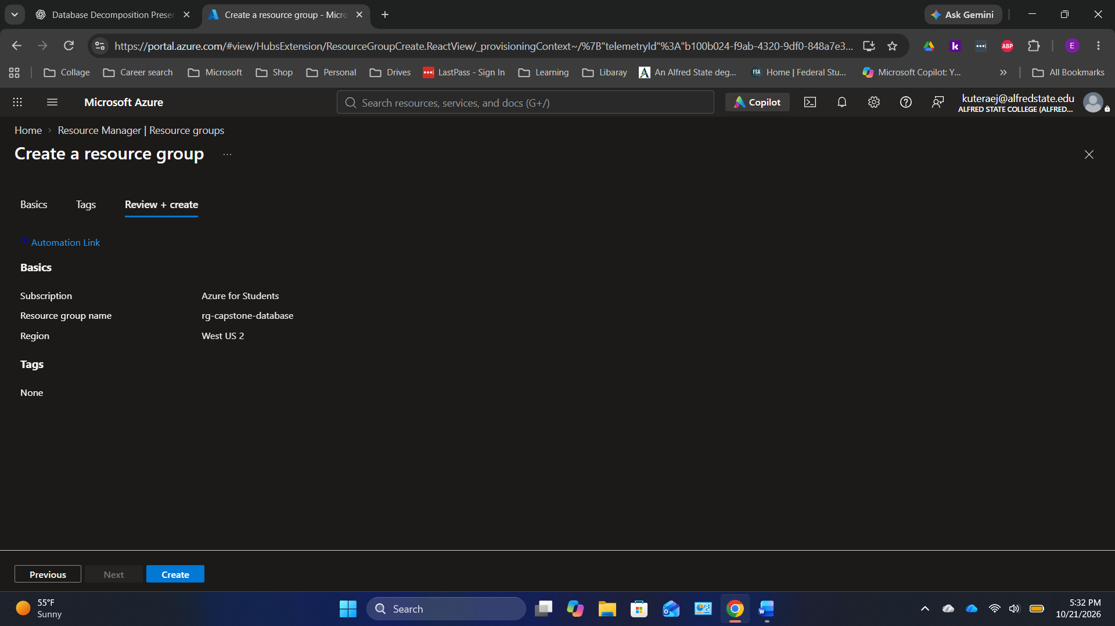
Original screenshot 1 of 44 — preserved in upload order.

Screen 02 — Azure resource group — created
Do this: After deployment, select Go to resource and open the resource group Overview page.
Check: The resource group is visible and initially has no databases inside.
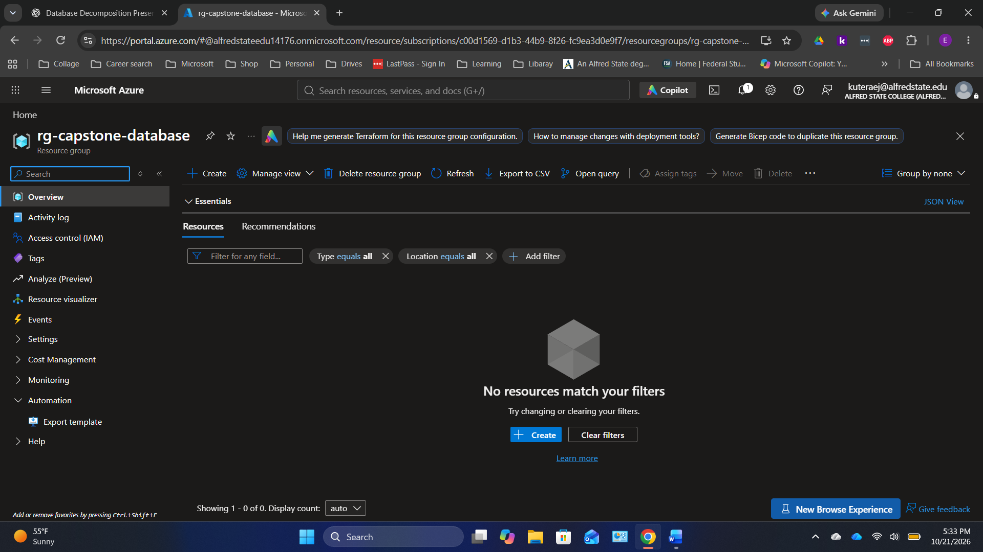
Original screenshot 2 of 44 — preserved in upload order.

Screen 03 — Azure SQL — start database creation
Do this: Search for SQL databases, select Create and choose the new resource group. Confirm the SQL free offer is shown if eligible.
Check: The subscription and resource group should match those used in the first step.
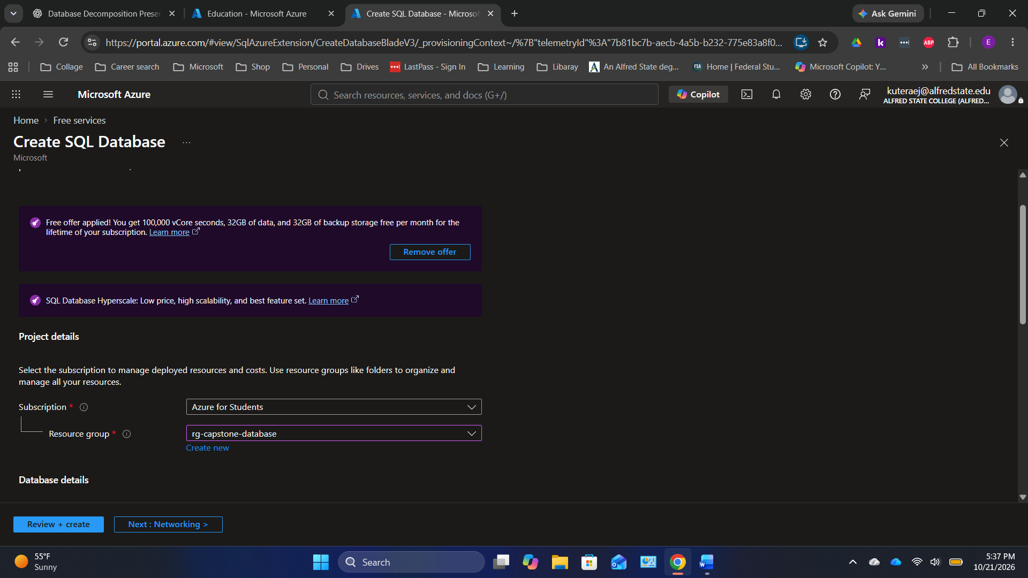
Original screenshot 3 of 44 — preserved in upload order.

Screen 04 — Azure SQL — create SQL server
Do this: In Database details, name your database capstone-sql-db. Select Create new server. Choose a globally unique SQL server name, a supported location, and your preferred authentication. Create a strong password locally if choosing SQL authentication.
Check: Never include passwords in screenshots or the handout.
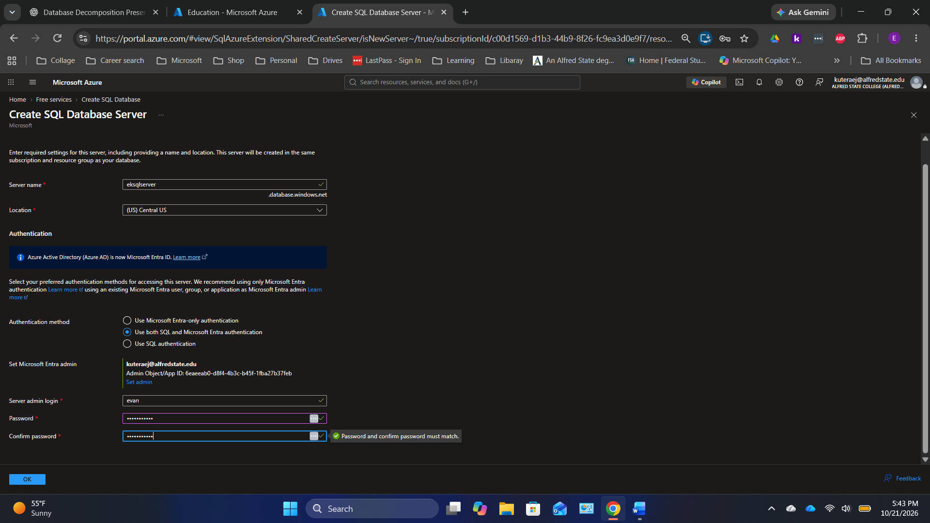
Original screenshot 4 of 44 — preserved in upload order.

Screen 05 — Azure SQL — review compute
Do this: On Basics, verify the database name, server and workload environment. Review the free database allocation carefully.
Check: Free offer must say Applied if you intend to use it.
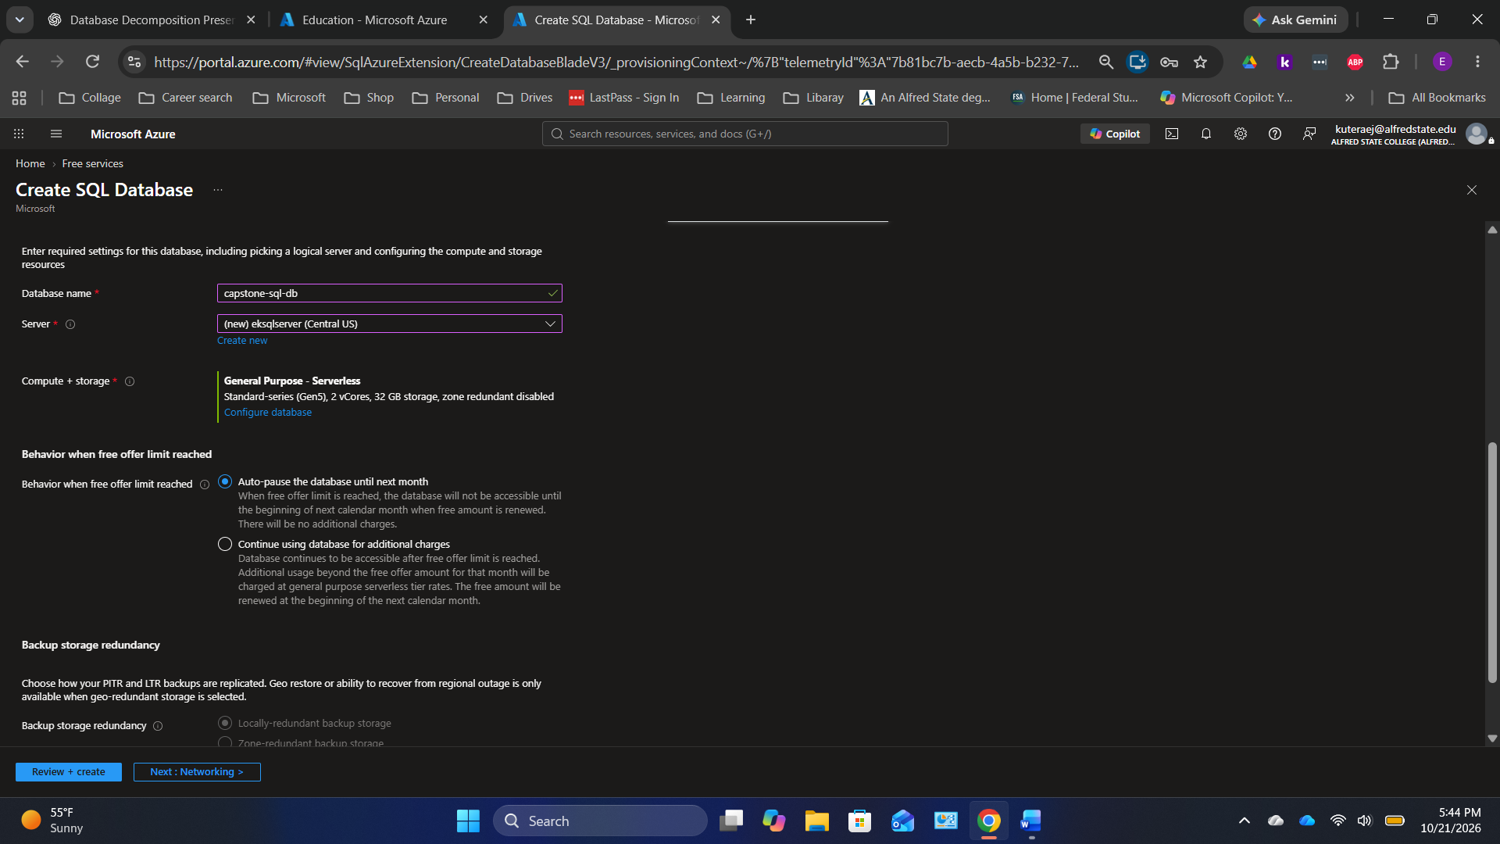
Original screenshot 5 of 44 — preserved in upload order.

Screen 06 — Azure SQL — select free-offer behavior
Do this: On the database compute/billing section, check that the free limit is enabled and usage overage is disabled or set to auto-pause on exhaustion.
Check: Do not choose options that permit overage charges for the lab.
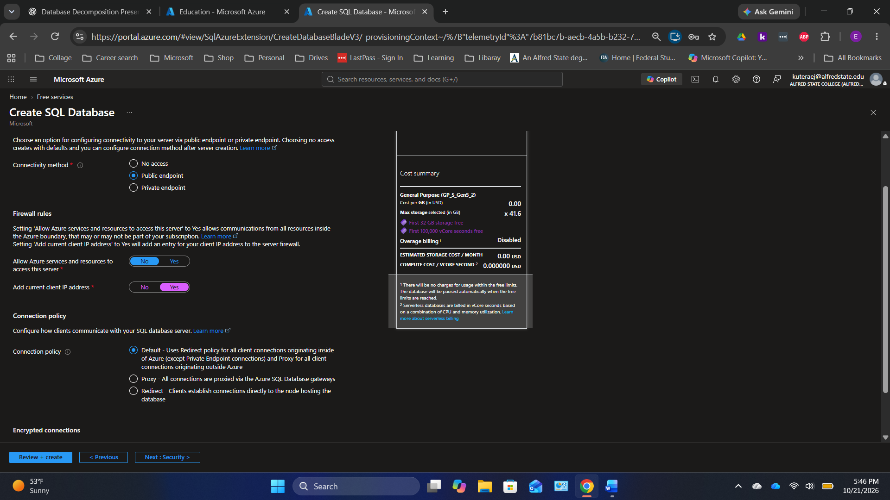
Original screenshot 6 of 44 — preserved in upload order.

Screen 07 — Azure SQL — confirm free usage settings
Do this: Review selected vCores, backup/storage allowance, auto-pause and estimated costs.
Check: Continue only when the selected pricing matches the intended student budget.
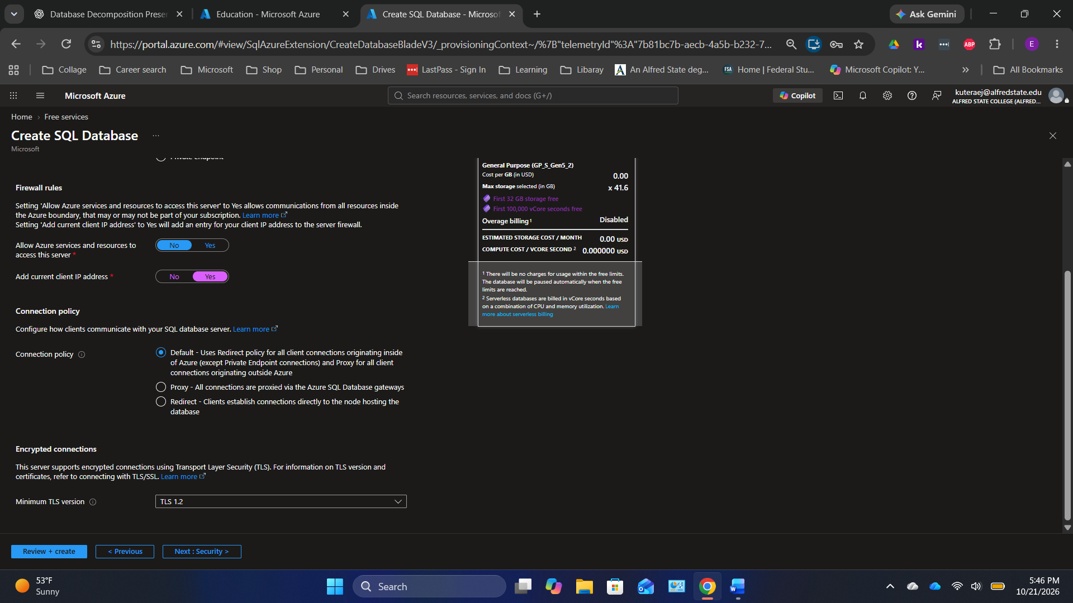
Original screenshot 7 of 44 — preserved in upload order.

Screen 08 — Azure SQL — Networking tab
Do this: Choose Public endpoint if you need to connect from a laptop, allow your client IP, keep broad Azure-services access disabled, and use TLS 1.2 or later.
Check: Restrict access to approved IP addresses.
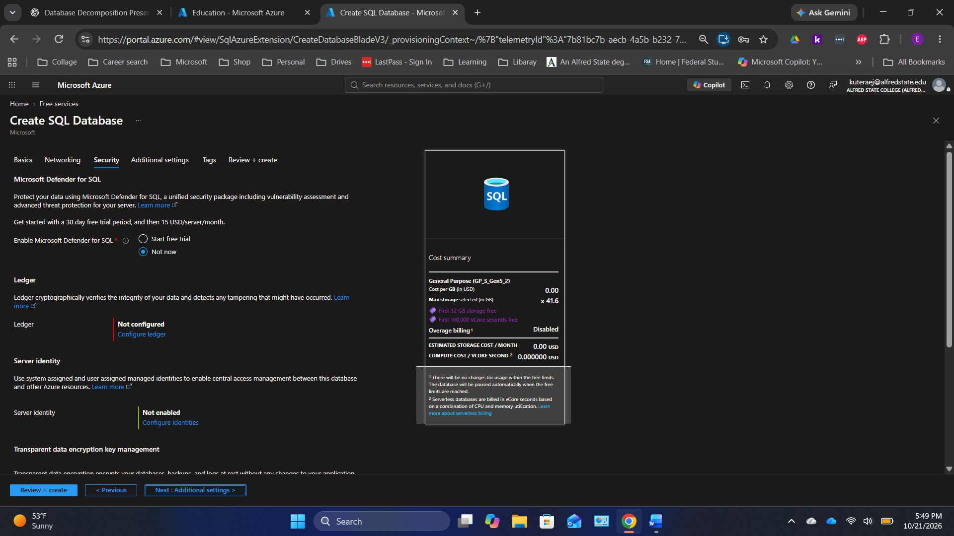
Original screenshot 8 of 44 — preserved in upload order.

Screen 09 — Azure SQL — Security tab
Do this: Leave optional paid Microsoft Defender for SQL disabled for this lab. Keep service-managed encryption unless you have a reason to change it.
Check: Do not activate a paid security trial unintentionally.
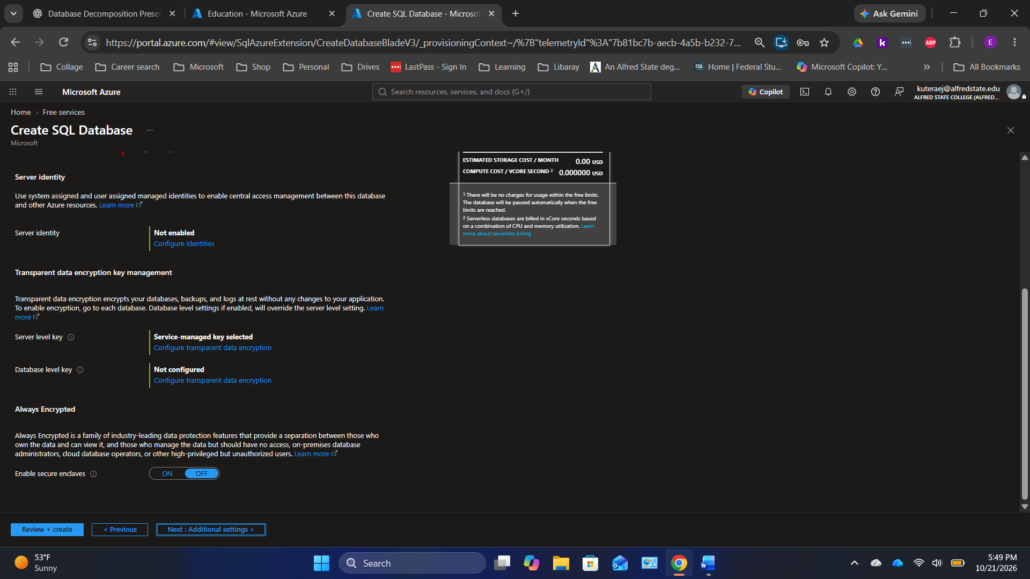
Original screenshot 9 of 44 — preserved in upload order.

Screen 10 — Azure SQL — additional security options
Do this: Review ledger, server identity and transparent data encryption settings. The default values are sufficient for the demonstration.
Check: The classroom exercise uses standard relational tables, not ledger features.
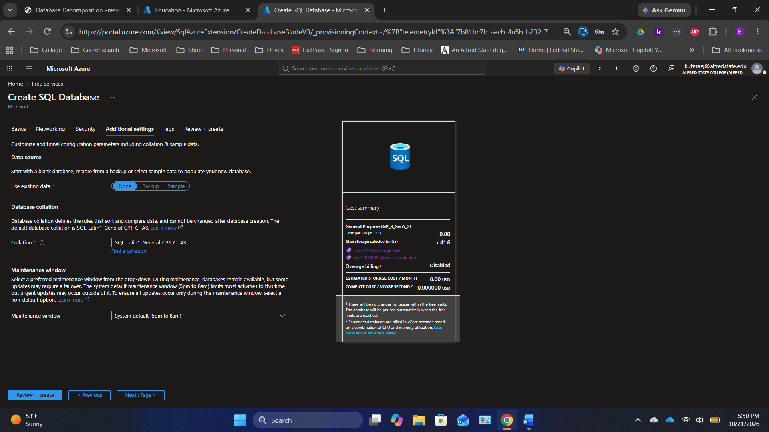
Original screenshot 10 of 44 — preserved in upload order.

Screen 11 — Azure SQL — additional database settings
Do this: Choose None under Use existing data so the new database starts blank. Keep the default collation unless your class requires another.
Check: Students will create their own Customers and Orders tables.
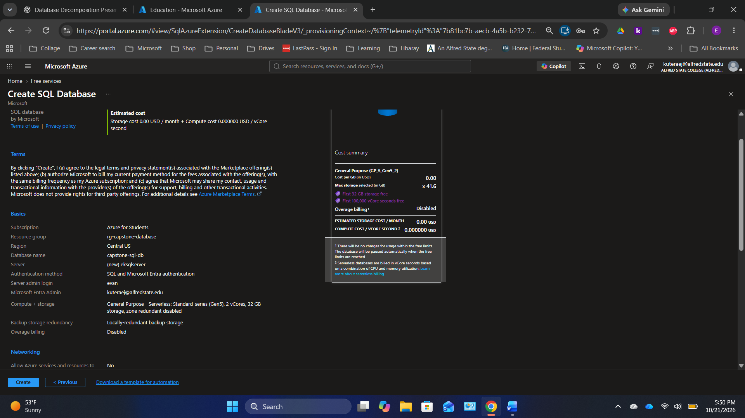
Original screenshot 11 of 44 — preserved in upload order.

Screen 12 — Azure SQL — review deployment
Do this: Select Review + create, check resource group, database name, server, network rules and free-limit behavior, and then select Create.
Check: Capture the validation screen as evidence of your selected configuration.
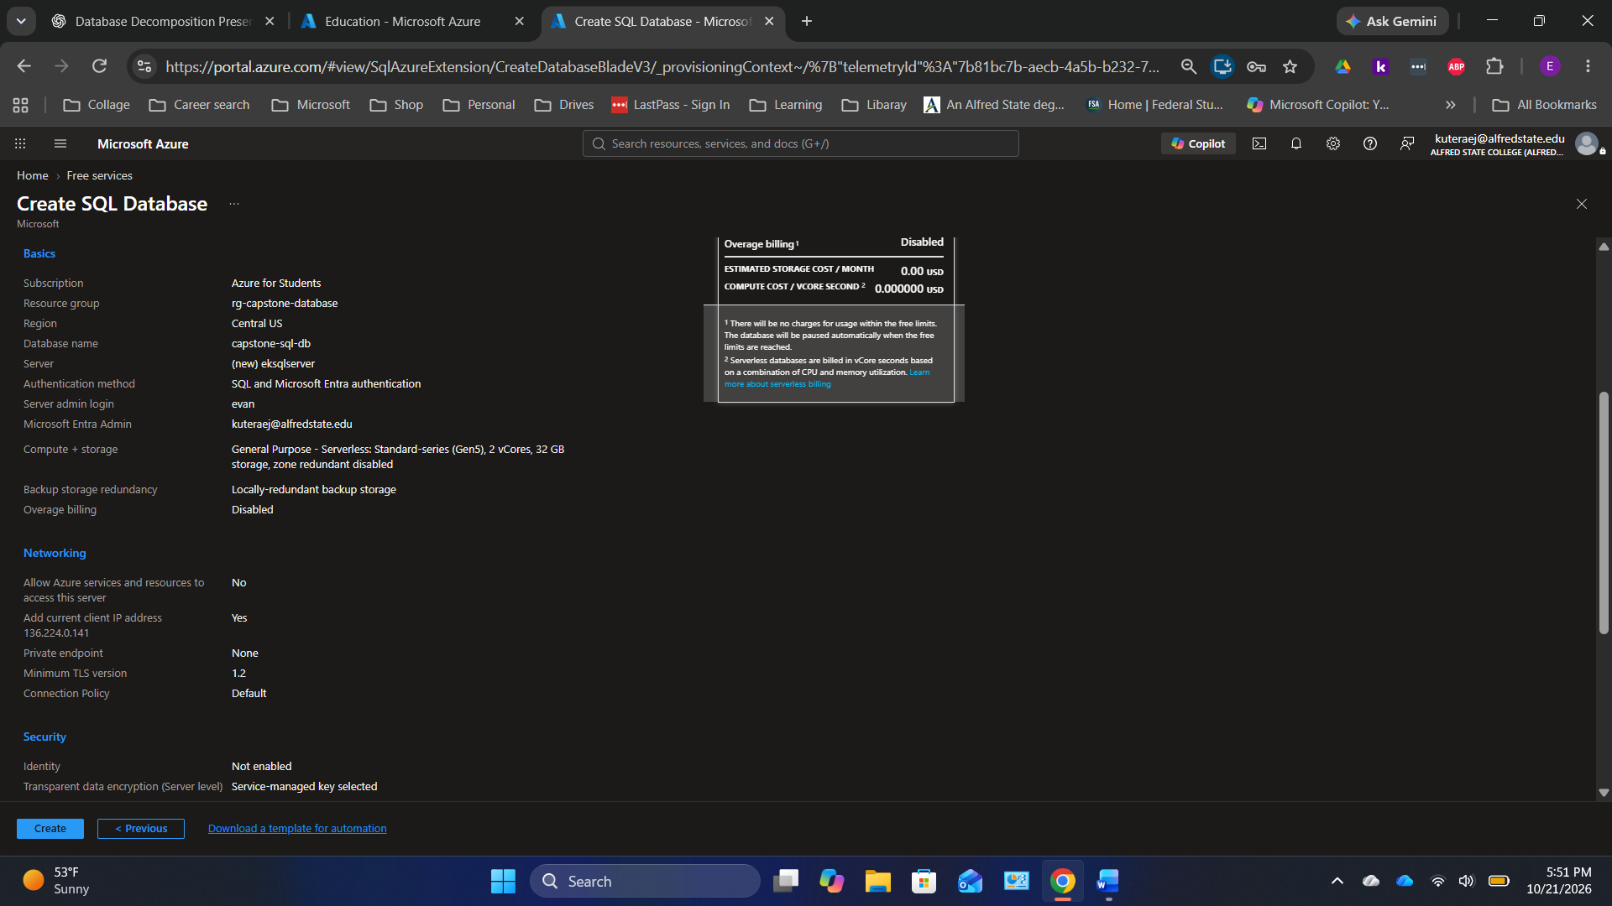
Original screenshot 12 of 44 — preserved in upload order.

Screen 13 — Azure SQL — final deployment review
Do this: Read the final configuration and billing summary; make sure no unexpected paid features were enabled.
Check: This is the last opportunity to catch settings mistakes.
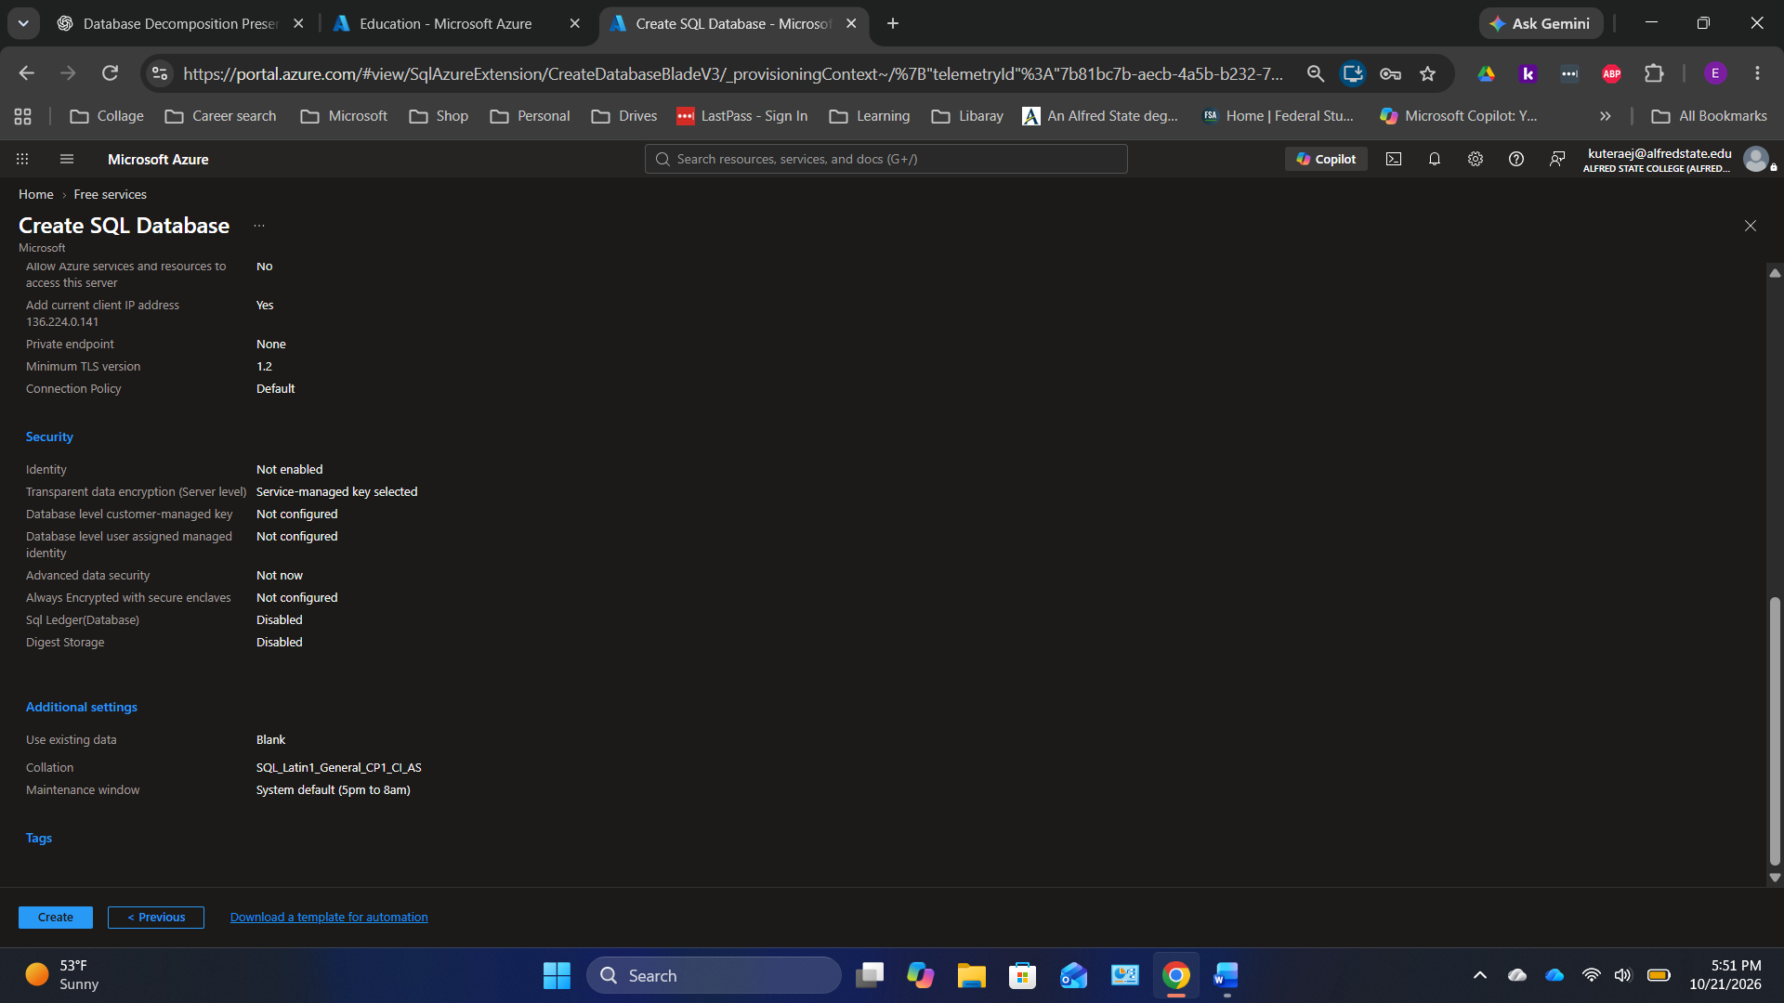
Original screenshot 13 of 44 — preserved in upload order.

Screen 14 — Azure SQL — deployment completed
Do this: Wait for Deployment succeeded, then choose Go to resource.
Check: Azure SQL resource deployment has finished.
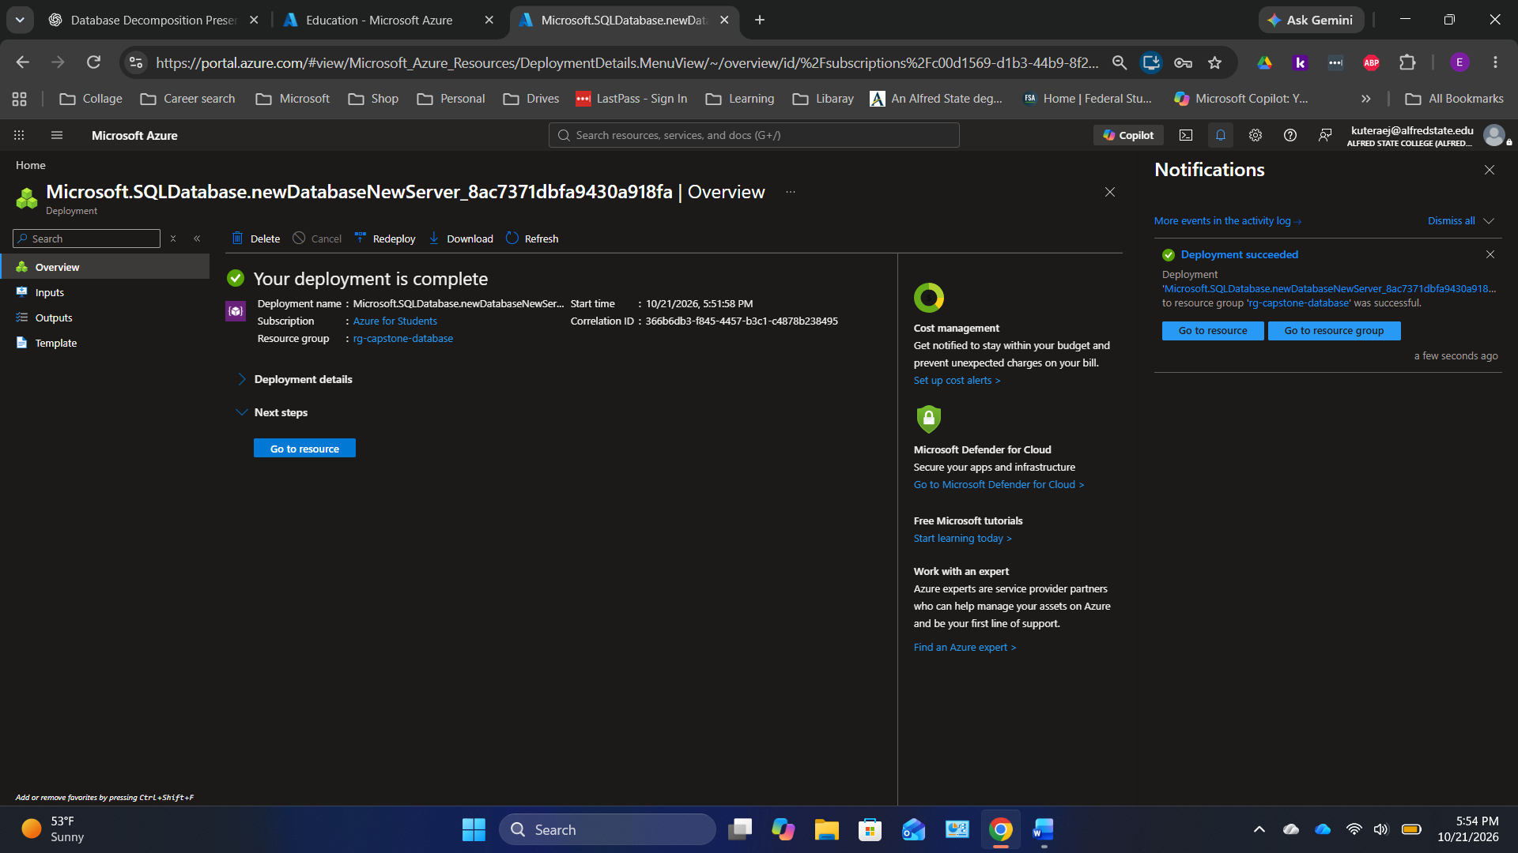
Original screenshot 14 of 44 — preserved in upload order.

Screen 15 — Azure SQL — database Overview
Do this: On Overview, confirm capstone-sql-db shows Online; note the SQL server name and free-offer/overage indicators.
Check: Do not copy the presenter’s SQL server name: classmates should use their own.
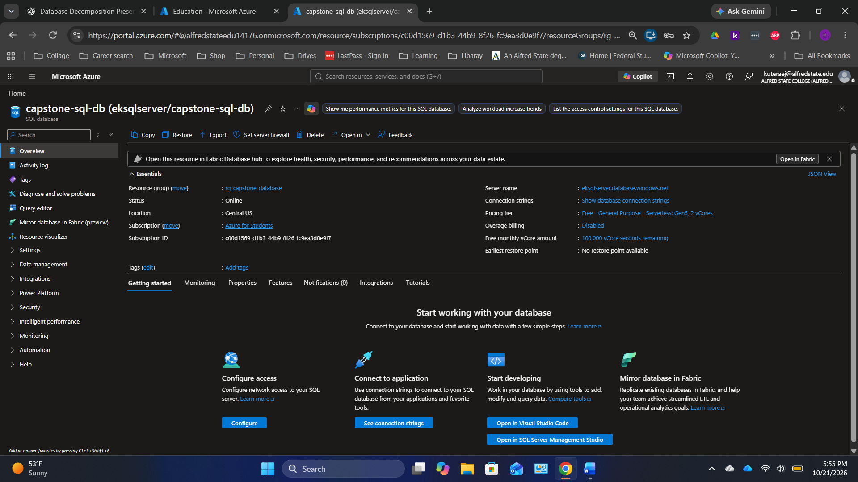
Original screenshot 15 of 44 — preserved in upload order.

Screen 16 — Azure SQL — sign in to Query editor
Do this: In the database sidebar, select Query editor, then sign in with the authentication method selected for your server. If networking blocks access, update the server firewall to allow your current IP.
Check: Never disclose SQL administrator credentials.
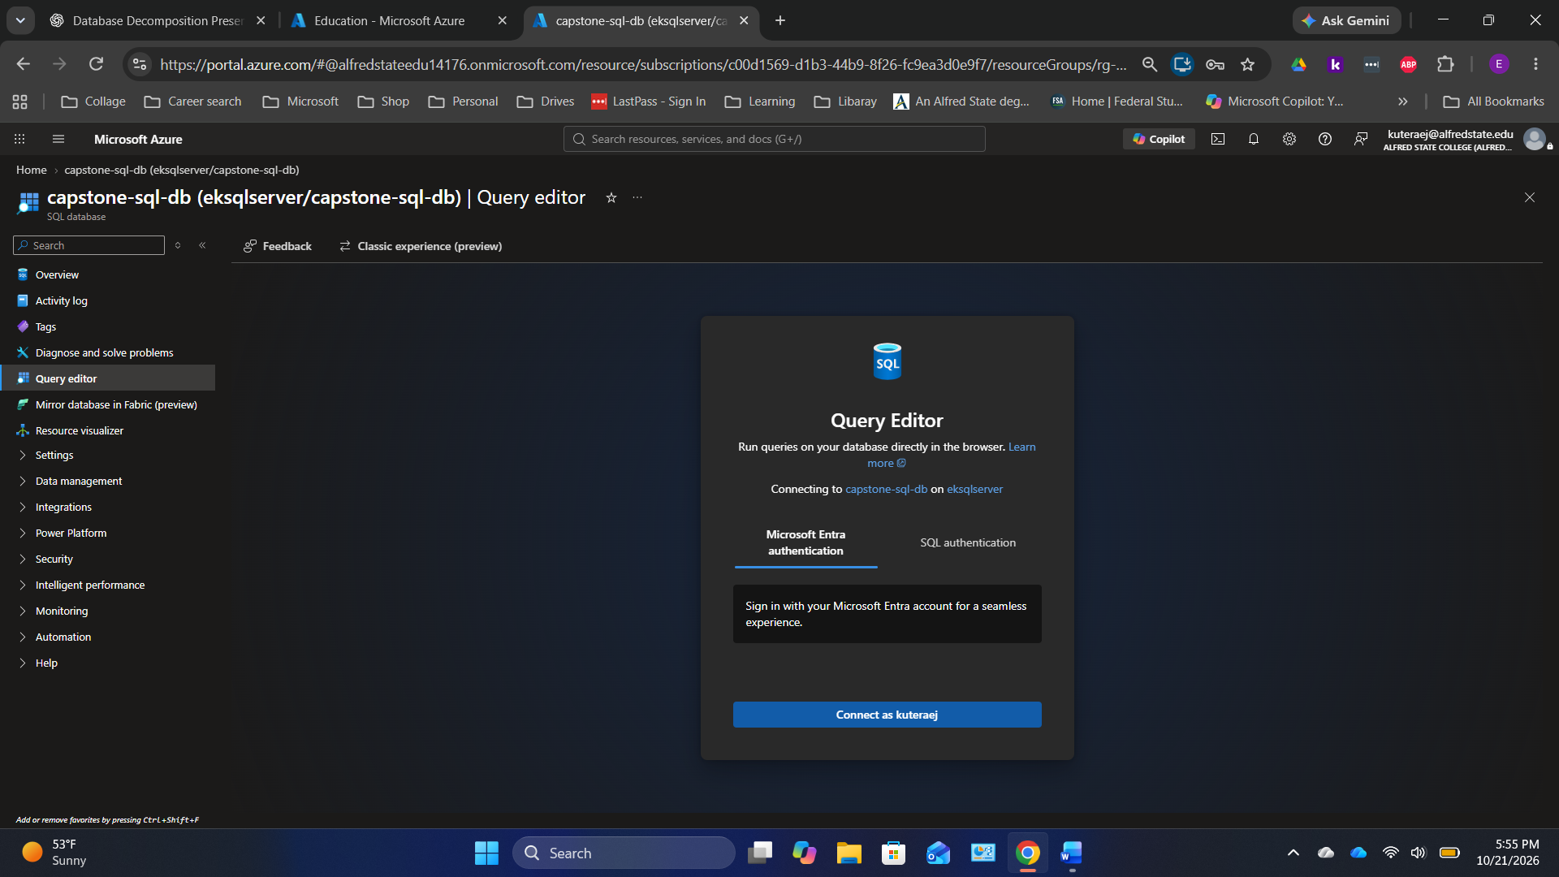
Original screenshot 16 of 44 — preserved in upload order.

Screen 17 — Azure SQL — open a new SQL query
Do this: Select New query. This is where you will type and execute SQL statements.
Check: A blank editor appears for capstone-sql-db.
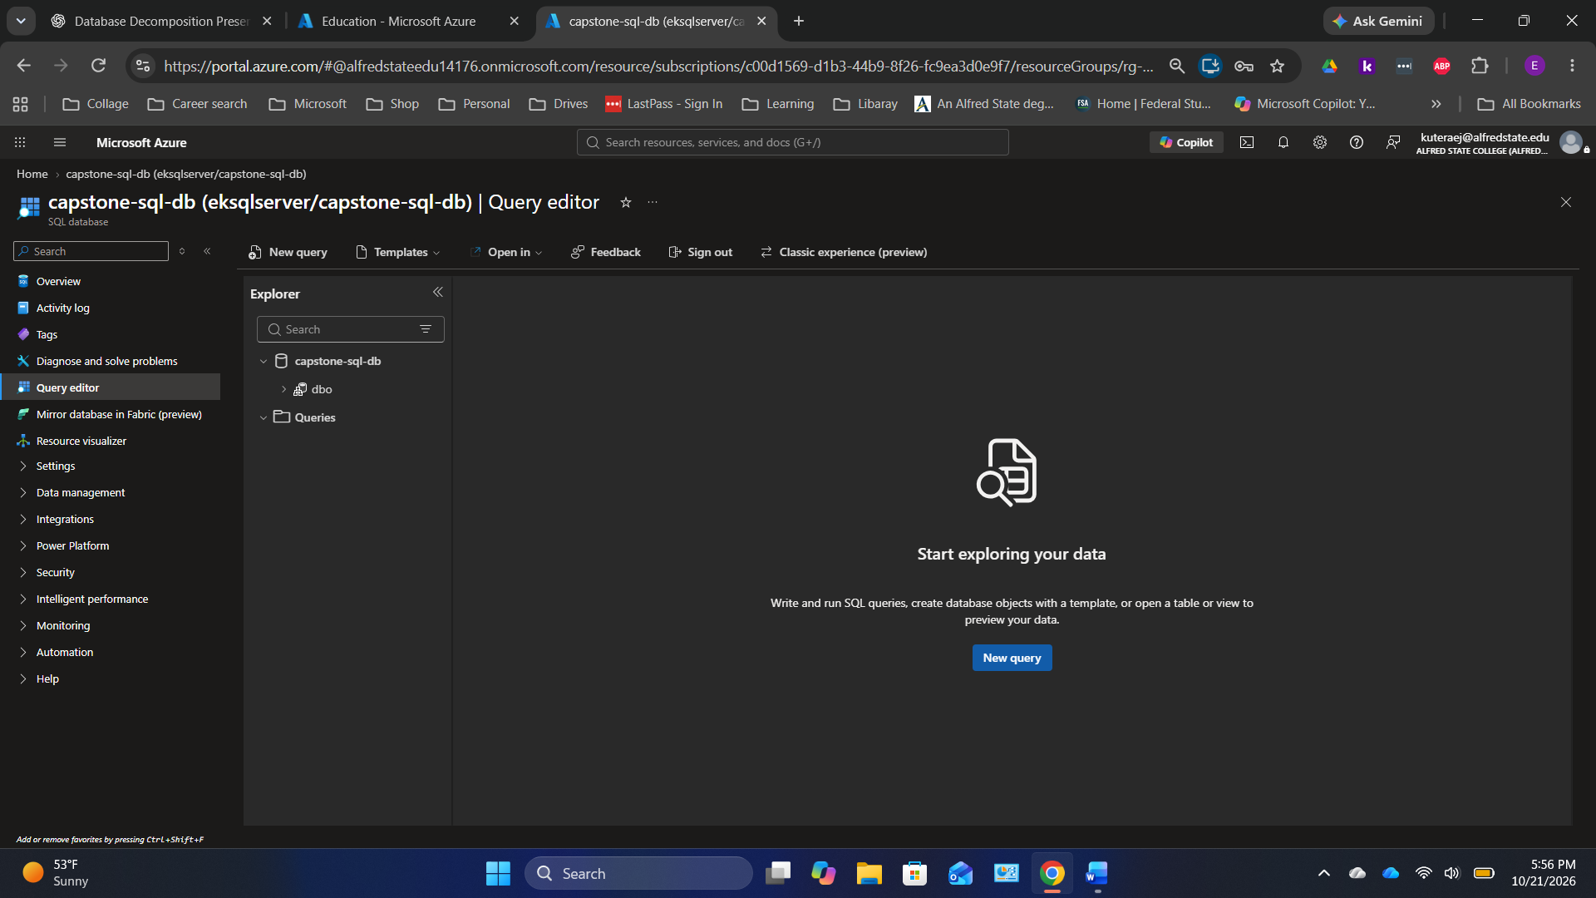
Original screenshot 17 of 44 — preserved in upload order.

Screen 18 — Azure SQL — enter CREATE TABLE statements
Do this: Paste the Customers and Orders table creation statements shown in the SQL Code section of this guide.
Check: Customers.customer_id is a primary key; Orders.customer_id is a foreign key.
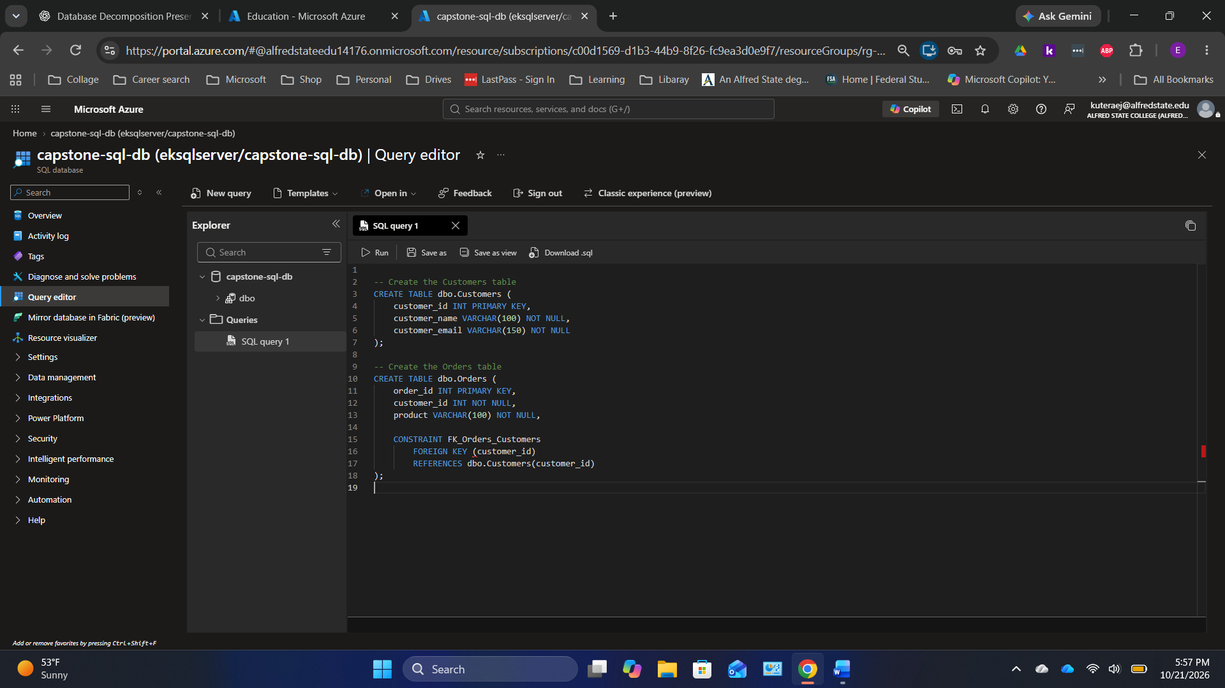
Original screenshot 18 of 44 — preserved in upload order.

Screen 19 — Azure SQL — verify tables created
Do this: Click Run once. Expand dbo > Tables in Explorer and confirm Customers and Orders appear.
Check: You should see Query executed successfully.
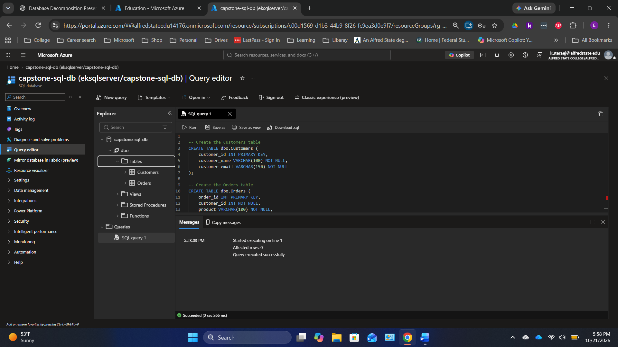
Original screenshot 19 of 44 — preserved in upload order.

Screen 20 — Azure SQL — insert sample rows
Do this: Open a new query and run the sample INSERT statements from the SQL Code section once.
Check: Expect 3 customer rows plus 5 order rows.
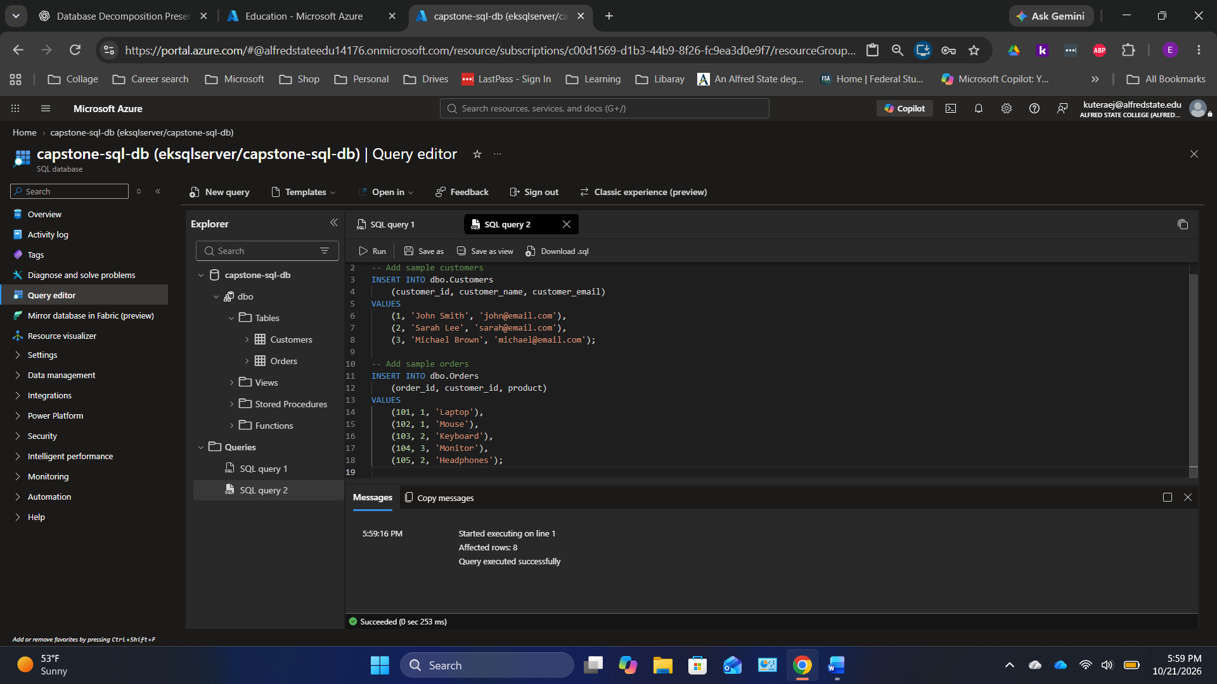
Original screenshot 20 of 44 — preserved in upload order.

Screen 21 — Azure SQL — inspect Customers table
Do this: Open the Customers table from Explorer to inspect its rows.
Check: Verify John Smith, Sarah Lee and Michael Brown are present.
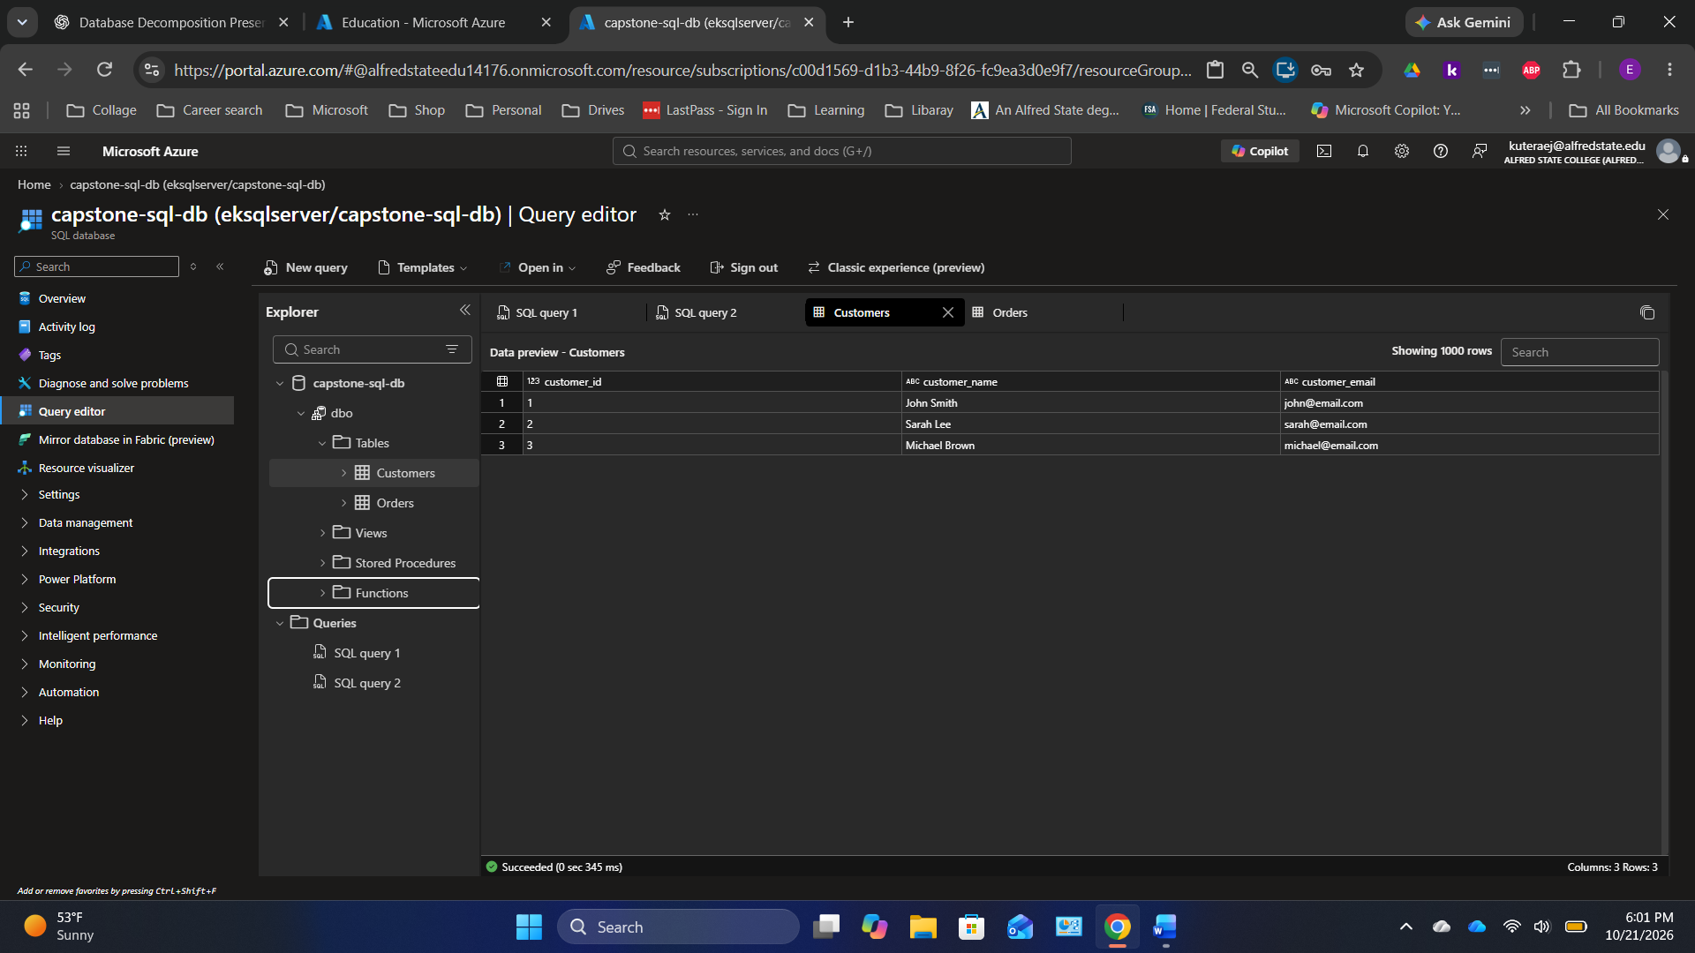
Original screenshot 21 of 44 — preserved in upload order.

Screen 22 — Azure SQL — inspect Orders table
Do this: Open the Orders table from Explorer and view the example product orders.
Check: Five orders should be present; each order stores customer_id.
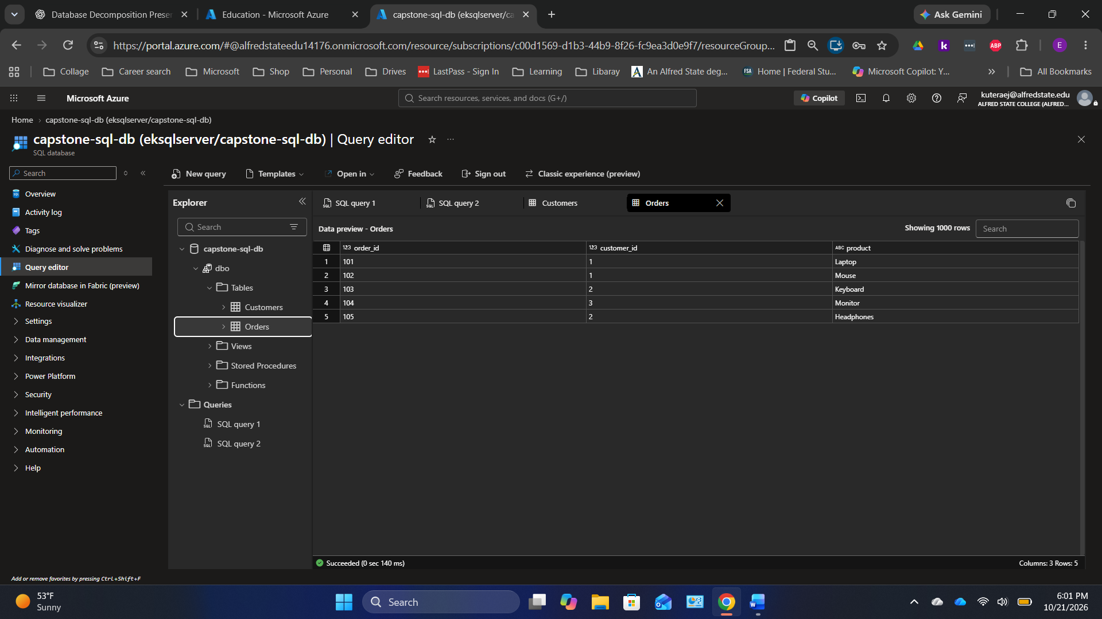
Original screenshot 22 of 44 — preserved in upload order.

Screen 23 — Azure SQL — run INNER JOIN
Do this: Open a new query and run the INNER JOIN from the SQL Code section.
Check: The result combines customer name/email with each order without storing them repeatedly.
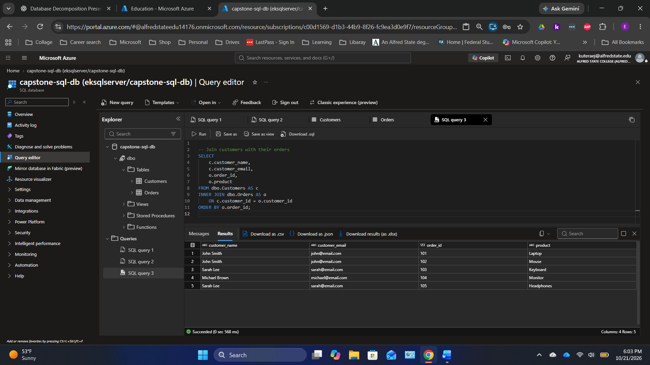
Original screenshot 23 of 44 — preserved in upload order.

Screen 24 — Azure Cosmos DB — find the service
Do this: In the Azure Portal, search Azure Cosmos DB and select Create.
Check: Choose Azure Cosmos DB for NoSQL, not MongoDB or another API.
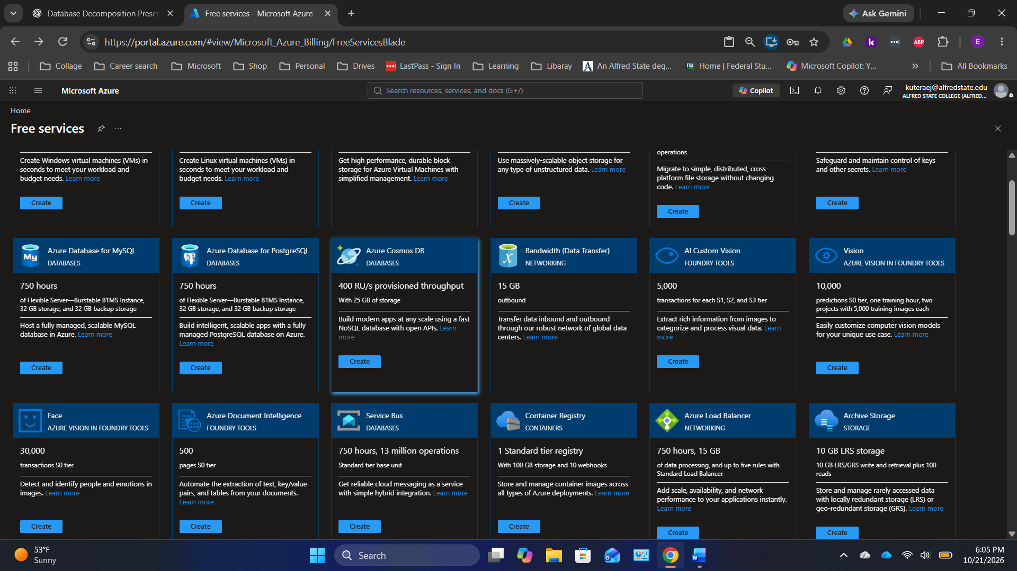
Original screenshot 24 of 44 — preserved in upload order.

Screen 25 — Azure Cosmos DB — select NoSQL
Do this: Choose Azure Cosmos DB for NoSQL on the API selection screen, then select Create.
Check: The document API will store different JSON product attributes.
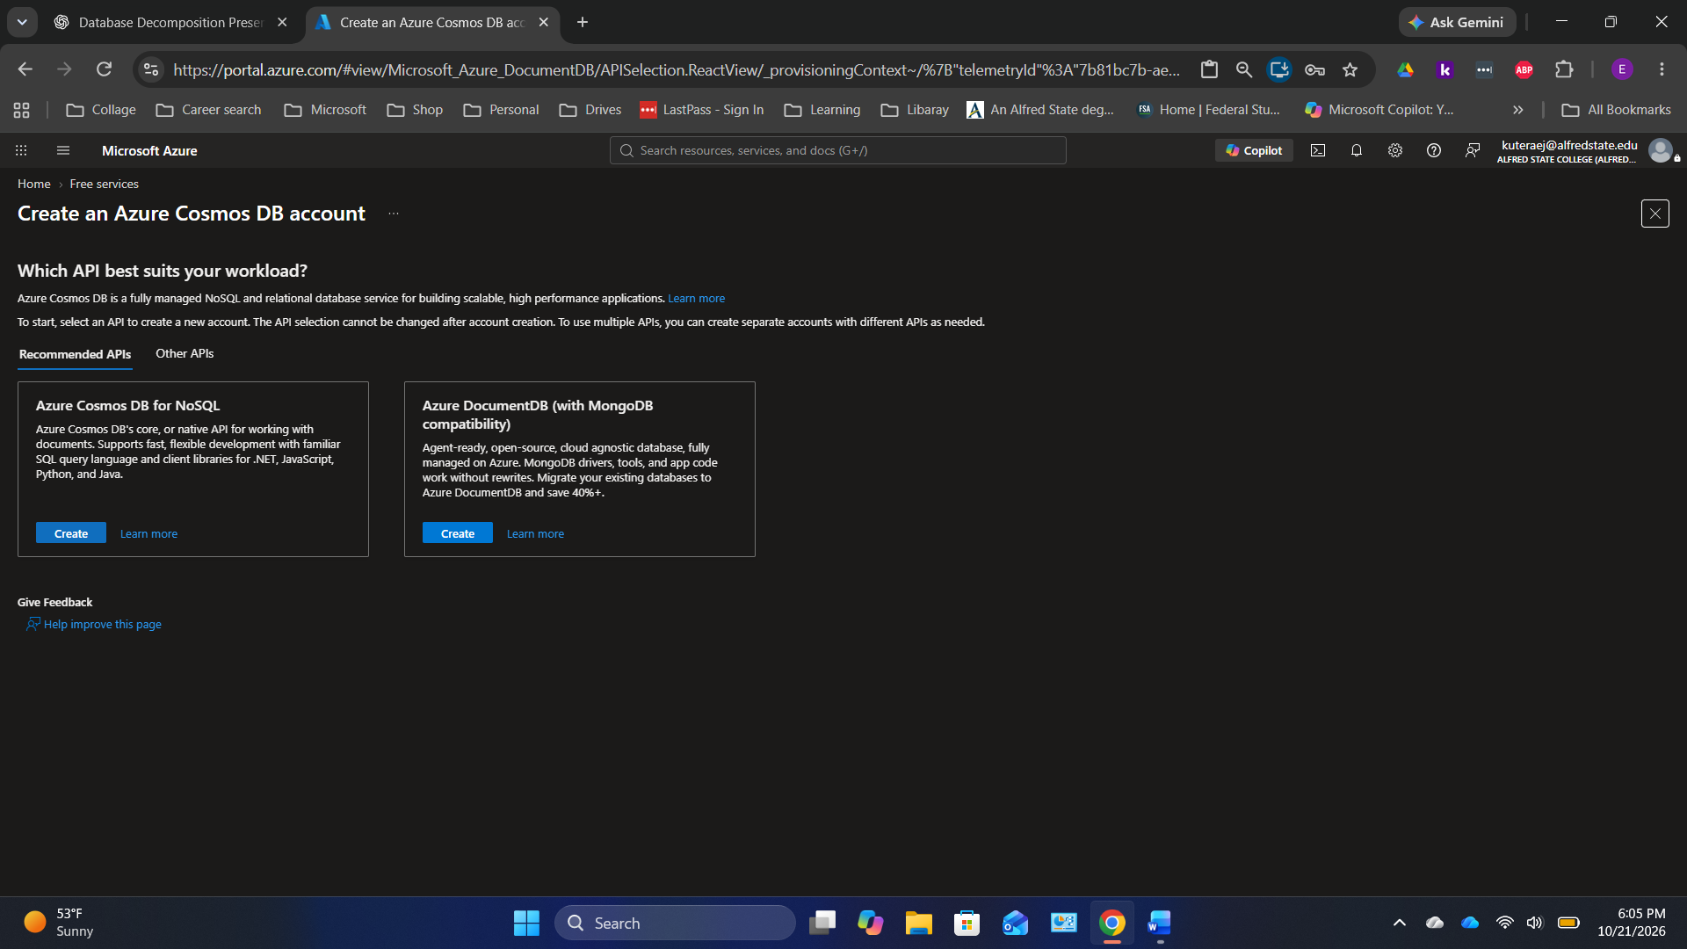
Original screenshot 25 of 44 — preserved in upload order.

Screen 26 — Azure Cosmos DB — Basics settings
Do this: Select the resource group rg-capstone-database, choose a globally unique Cosmos account name, select an available region, and select Provisioned throughput. Apply the Free Tier Discount if eligible and set an account throughput limit.
Check: The presenter used capstone-cosmos-lab-2026; students need their own unique names.
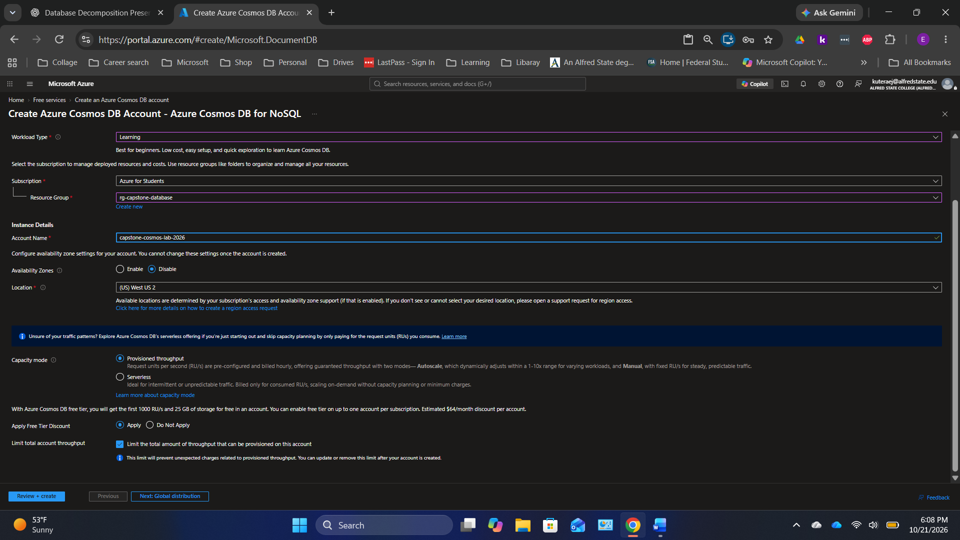
Original screenshot 26 of 44 — preserved in upload order.

Screen 27 — Azure Cosmos DB — Global distribution
Do this: Keep geo-redundancy and multi-region writes disabled for this introductory lab.
Check: A single region is enough for the example.
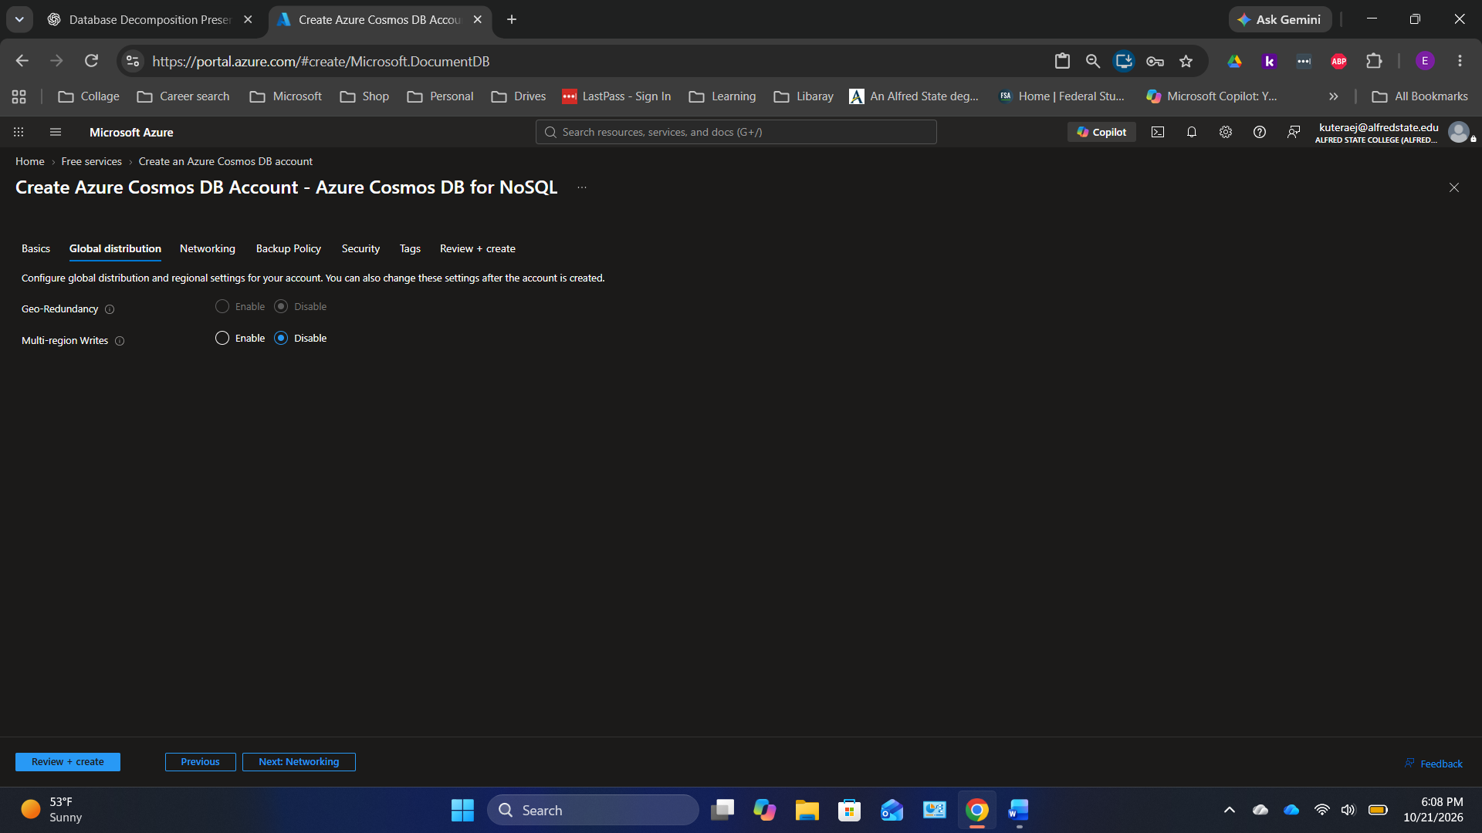
Original screenshot 27 of 44 — preserved in upload order.

Screen 28 — Azure Cosmos DB — Networking
Do this: Select Public endpoint (selected networks). Allow access from the current client IP and, if required, Azure Portal middleware IPs. Keep TLS 1.2.
Check: Avoid All networks when you can allow specific IPs.
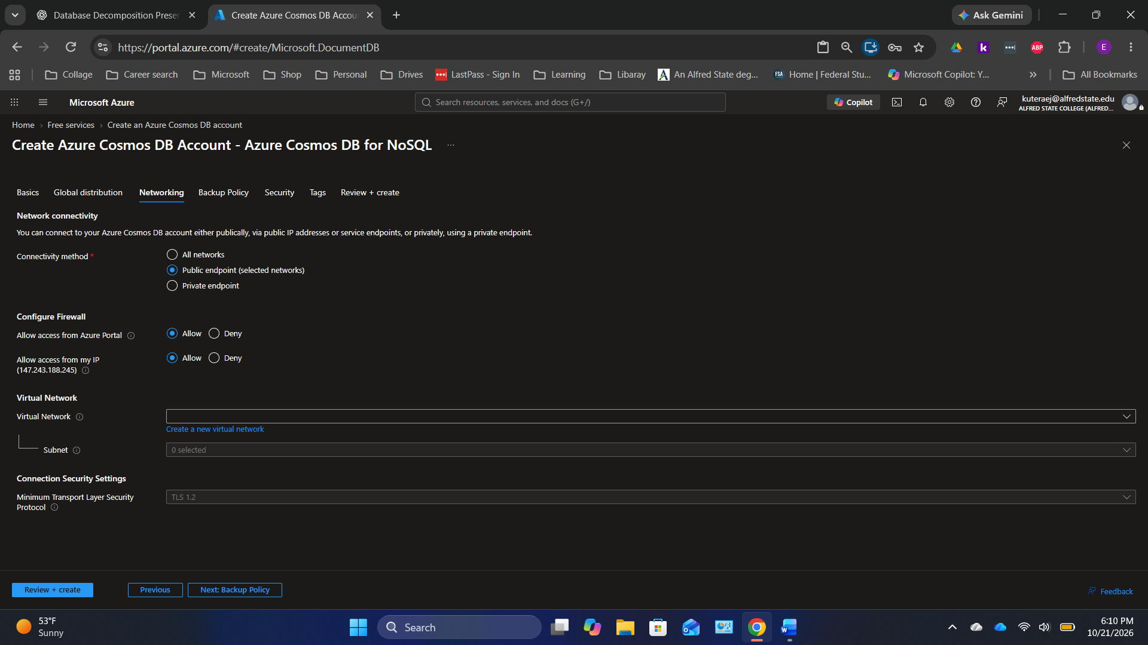
Original screenshot 28 of 44 — preserved in upload order.

Screen 29 — Azure Cosmos DB — Backup policy
Do this: Keep periodic backup at the defaults unless your course specifies otherwise. The screenshots show a 240-minute backup interval and 8-hour retention.
Check: Do not select a paid retention tier without checking cost.
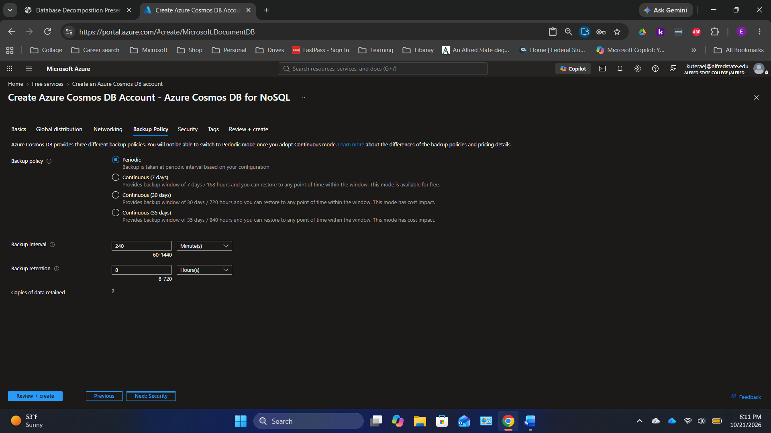
Original screenshot 29 of 44 — preserved in upload order.

Screen 30 — Azure Cosmos DB — Security
Do this: Keep service-managed encryption. Key-based authentication may be enabled for this learning setup, but never paste account keys in handouts.
Check: Microsoft Entra ID and scoped roles are preferable in production.
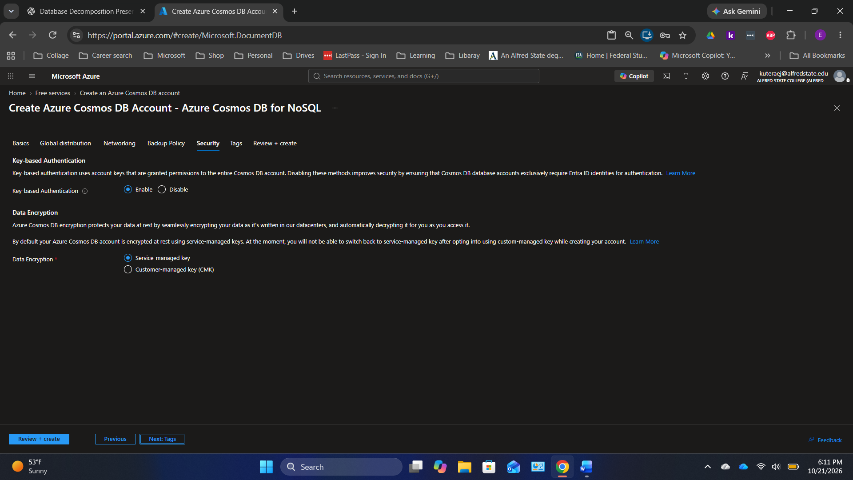
Original screenshot 30 of 44 — preserved in upload order.

Screen 31 — Azure Cosmos DB — validation
Do this: Select Review + create; verify the free-tier discount, provisioned capacity, resource group, account name, network restrictions and overall configuration.
Check: Continue only when validation succeeds.
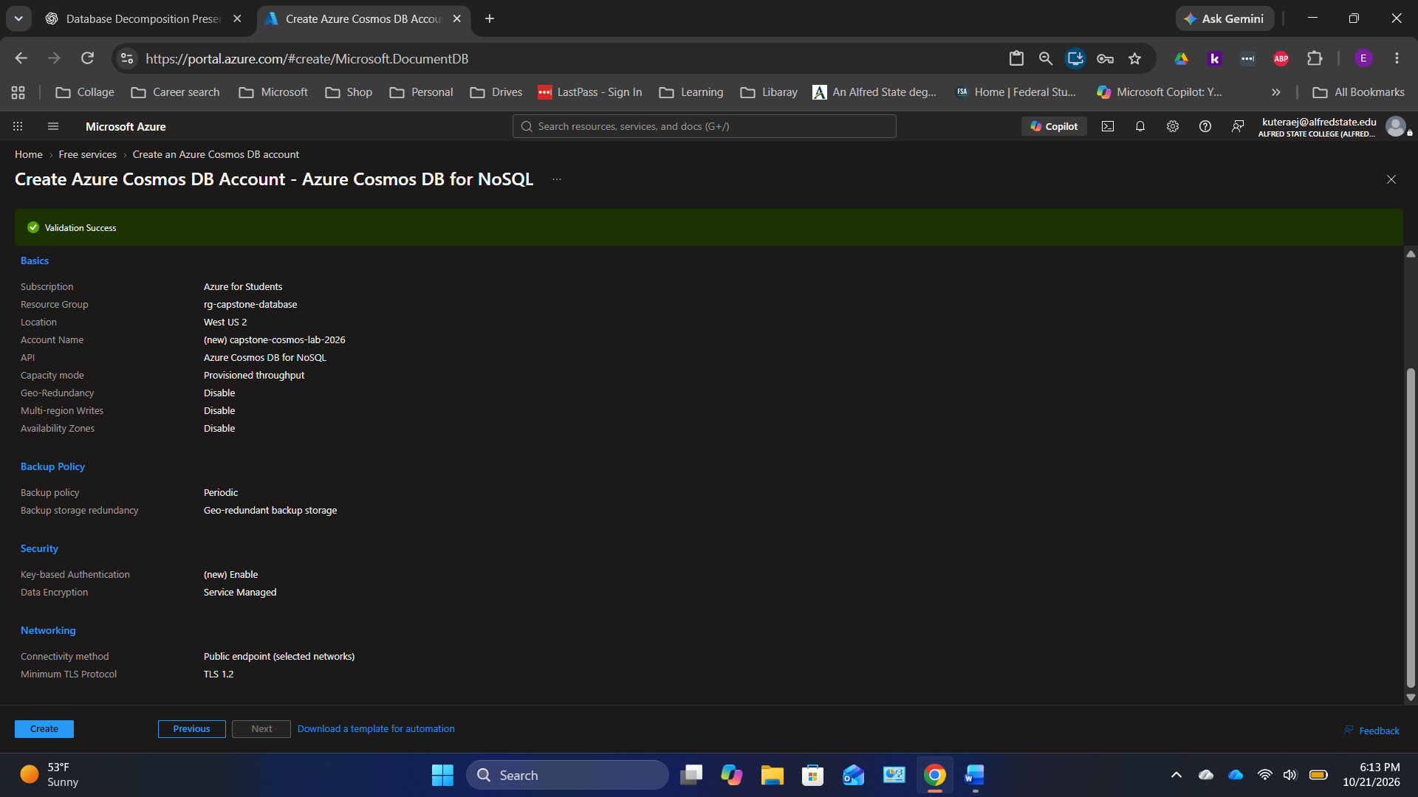
Original screenshot 31 of 44 — preserved in upload order.

Screen 32 — Azure Cosmos DB — deployment succeeded
Do this: Select Create, then Go to resource once Azure reports the deployment completed.
Check: The NoSQL account is available in the resource group.
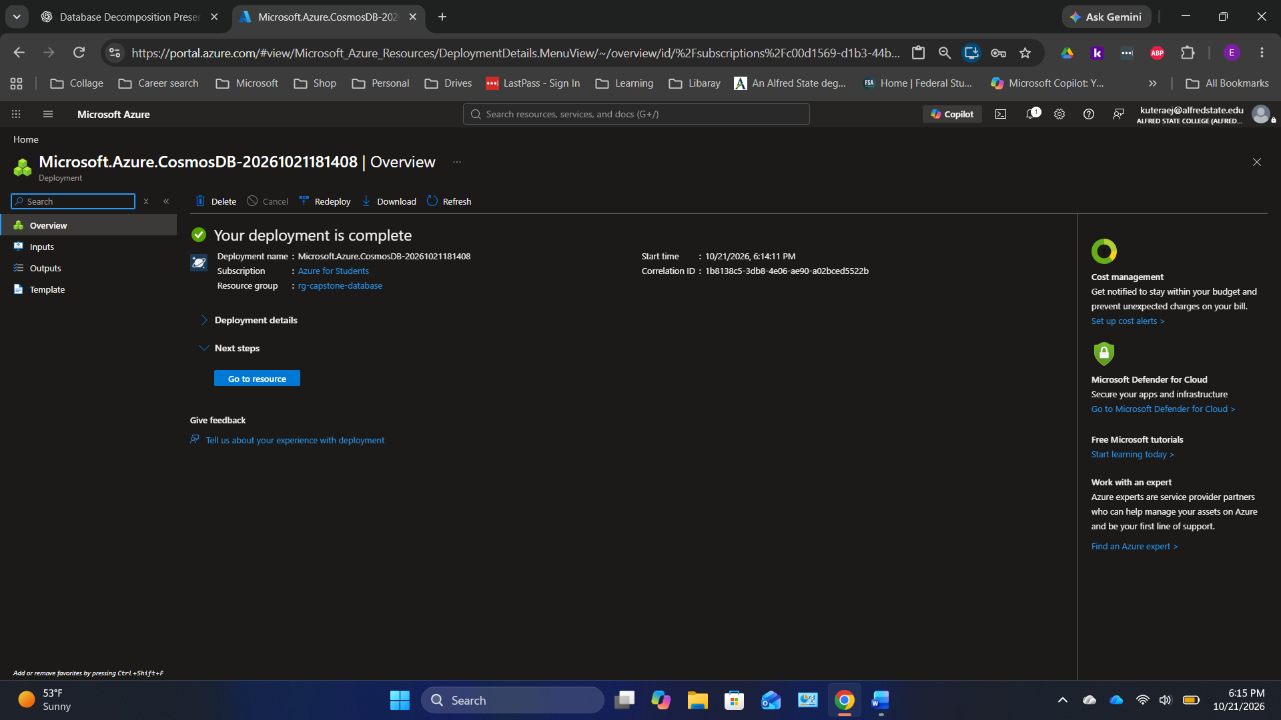
Original screenshot 32 of 44 — preserved in upload order.

Screen 33 — Azure Cosmos DB — account Overview
Do this: Confirm account Online, Free Tier Discount opted in and the total throughput limit set as expected.
Check: The presenter’s account used a 1,000 RU/s total limit.
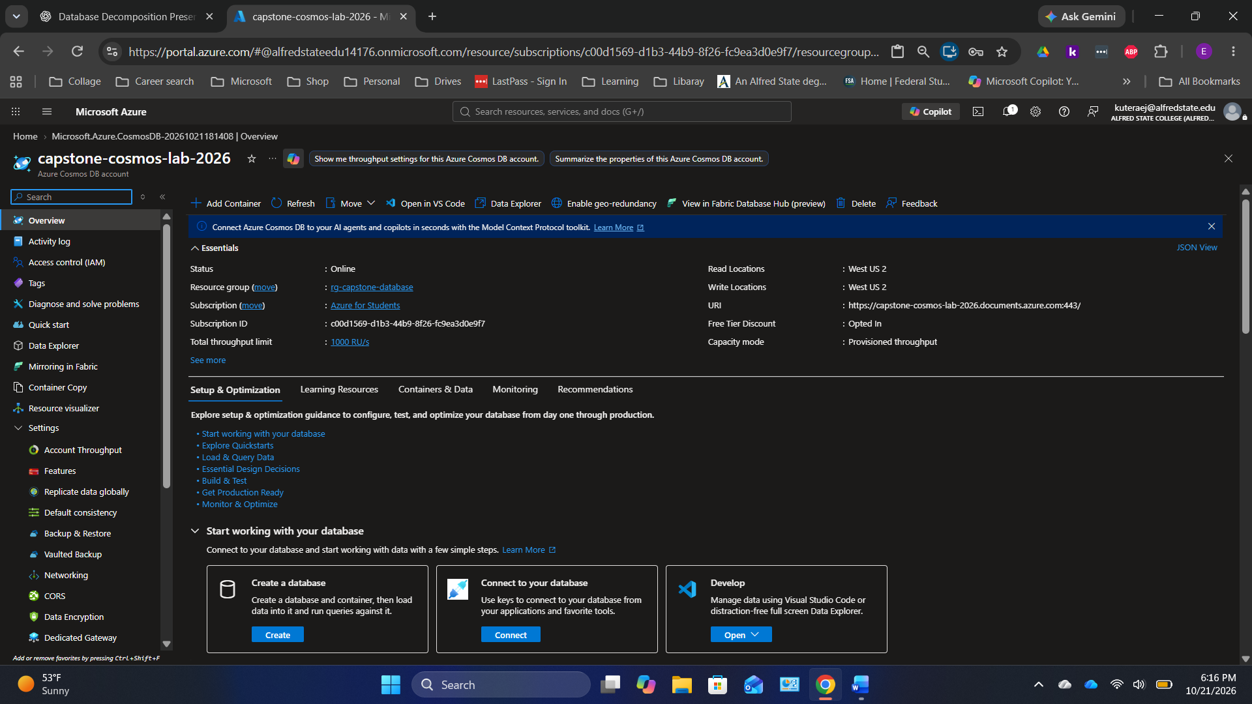
Original screenshot 33 of 44 — preserved in upload order.

Screen 34 — Azure Cosmos DB — open Data Explorer
Do this: Select Data Explorer from the Cosmos DB navigation.
Check: The explorer will contain the database and its document containers.
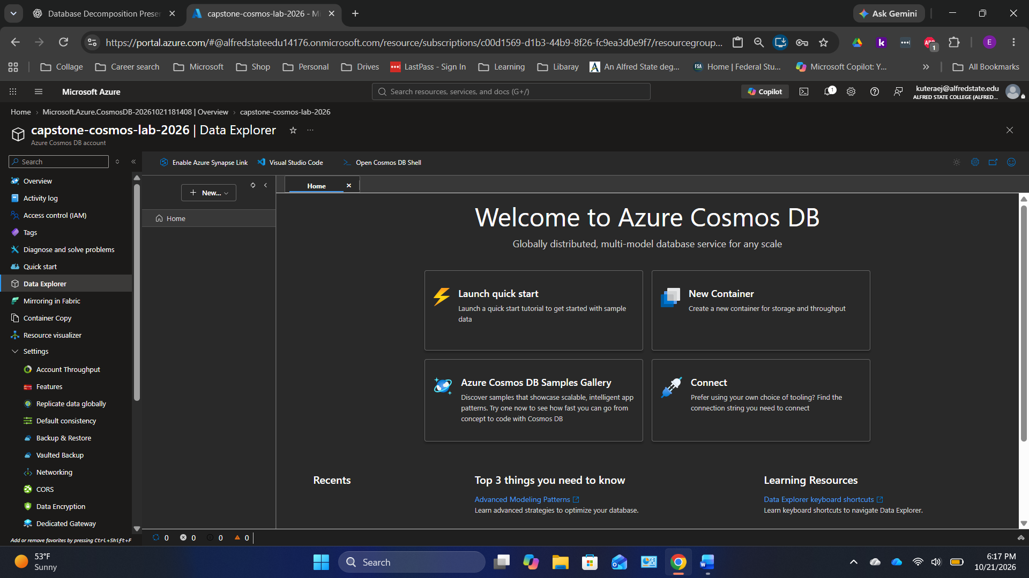
Original screenshot 34 of 44 — preserved in upload order.

Screen 35 — Azure Cosmos DB — New Container
Do this: Select New Container, choose Create new database, enter CapstoneStore, set container to Products, partition key to /category, and Manual throughput at 400 RU/s.
Check: Do not create unnecessary extra containers with provisioned throughput.
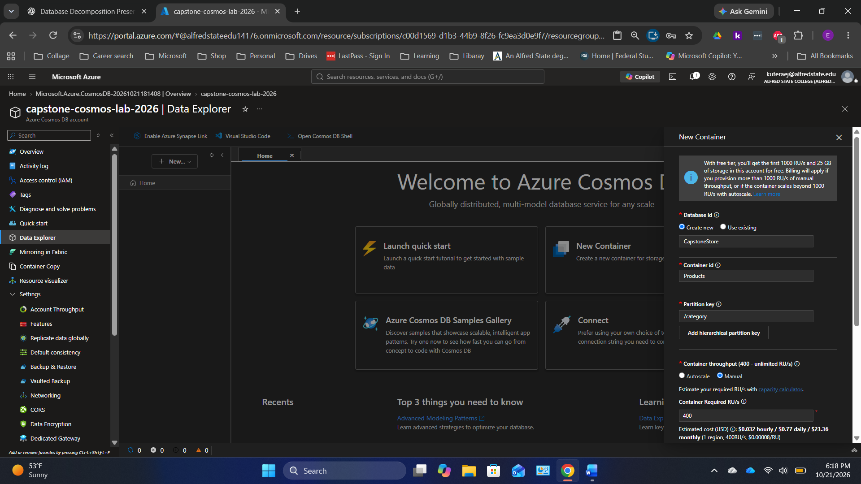
Original screenshot 35 of 44 — preserved in upload order.

Screen 36 — Azure Cosmos DB — check container tree
Do this: Expand CapstoneStore > Products. Select Items.
Check: Items and Scale & Settings should be listed under Products.
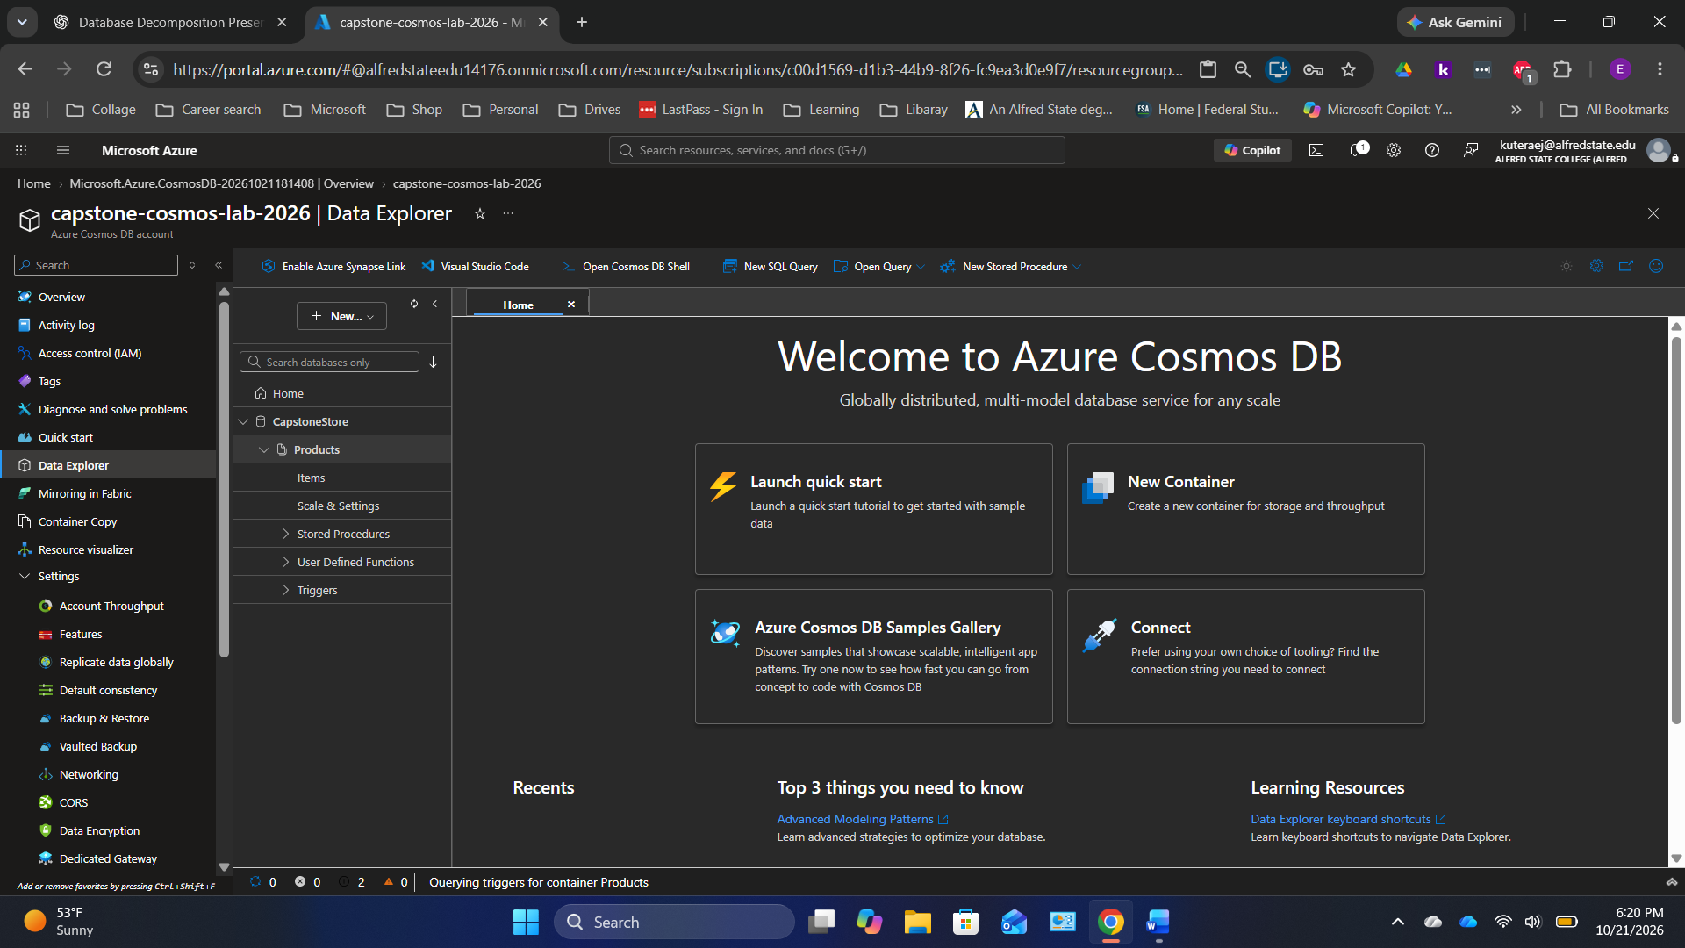
Original screenshot 36 of 44 — preserved in upload order.

Screen 37 — Azure Cosmos DB — enter Laptop JSON
Do this: Select New Item and paste the Laptop JSON from the JSON Code section, including id product-101 and category Electronics. Select Save.
Check: The Laptop document includes RAM, storage and processor.
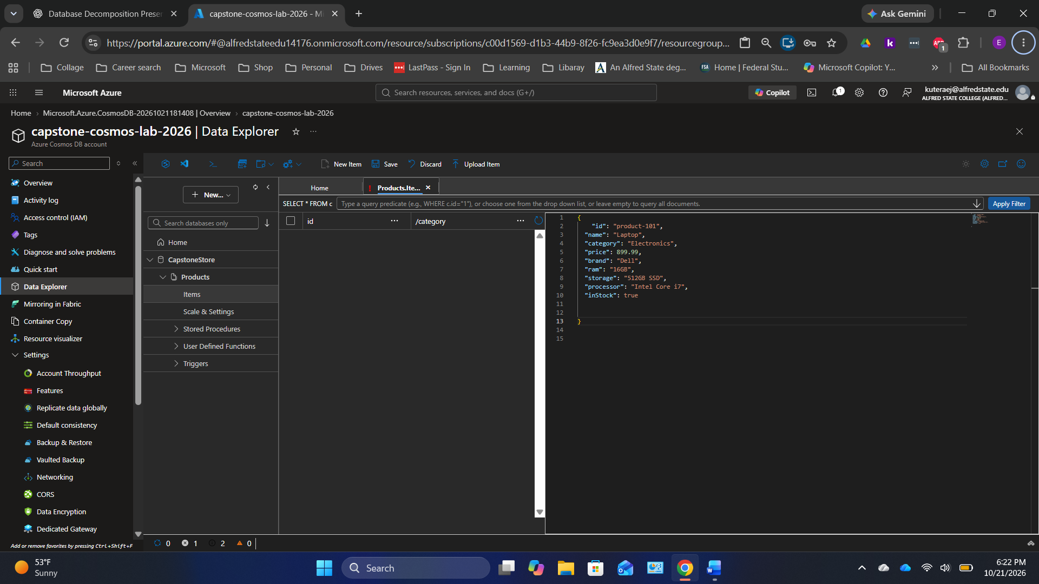
Original screenshot 37 of 44 — preserved in upload order.

Screen 38 — Azure Cosmos DB — firewall troubleshooting
Do this: If saving an item is blocked, read the IP shown in the error. Open Networking and add only that client IP to selected-network firewall rules, then save.
Check: The screenshot shows a blocked request; this is a troubleshooting example, not a successful save.
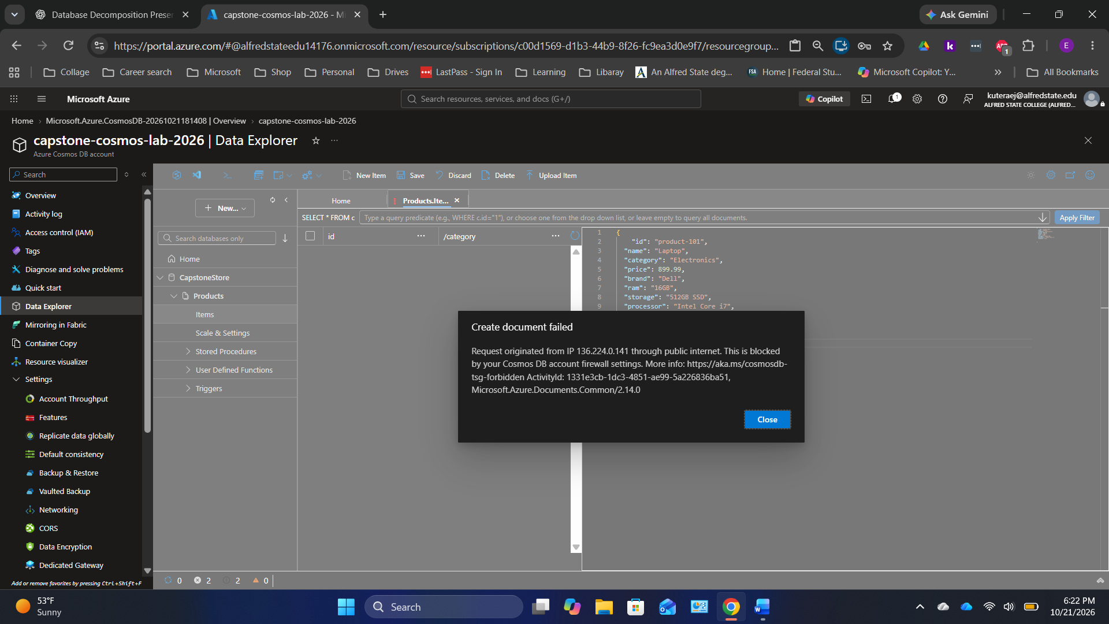
Original screenshot 38 of 44 — preserved in upload order.

Screen 39 — Azure Cosmos DB — firewall settings
Do this: Confirm Selected networks and add the IP reported by the error; keep the Azure Portal addresses required for the portal if present. Save the firewall rules.
Check: Network changes may take a short time to apply.
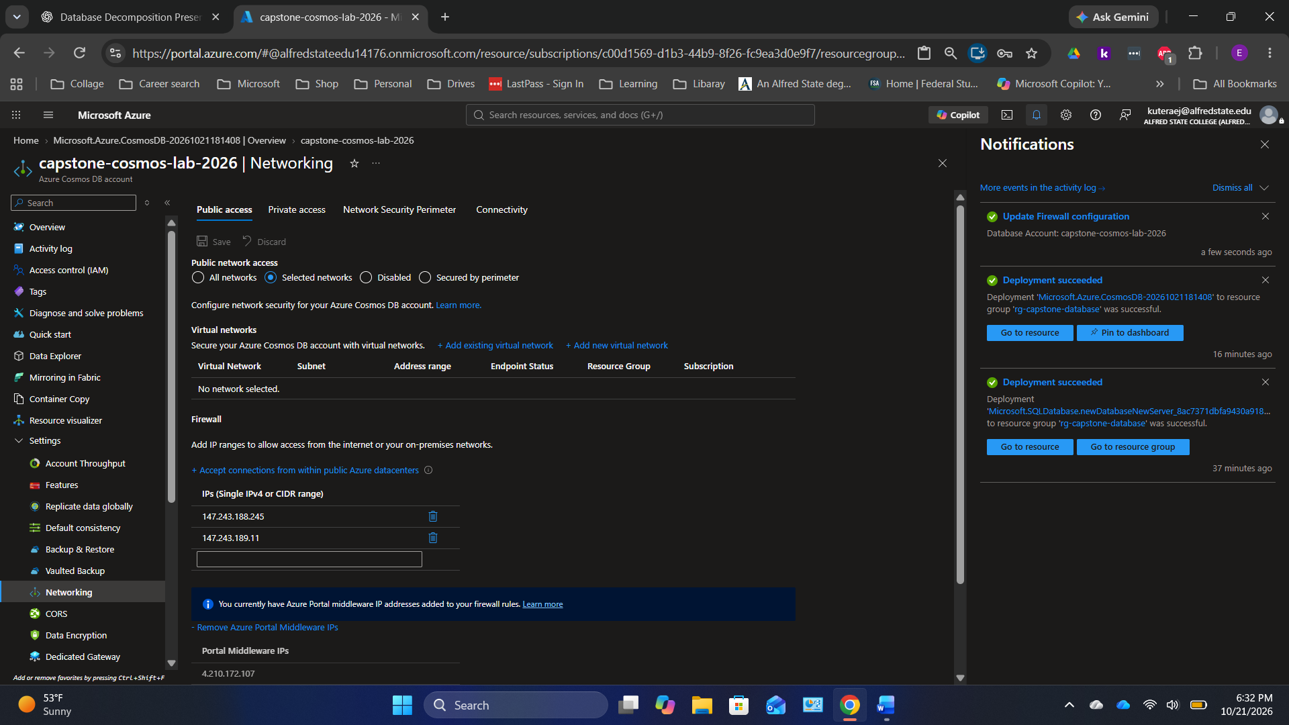
Original screenshot 39 of 44 — preserved in upload order.

Screen 40 — Azure Cosmos DB — firewall update confirmation
Do this: Verify the notification says the firewall update succeeded. Return to Data Explorer and save the document again.
Check: Do not reveal account keys while troubleshooting.
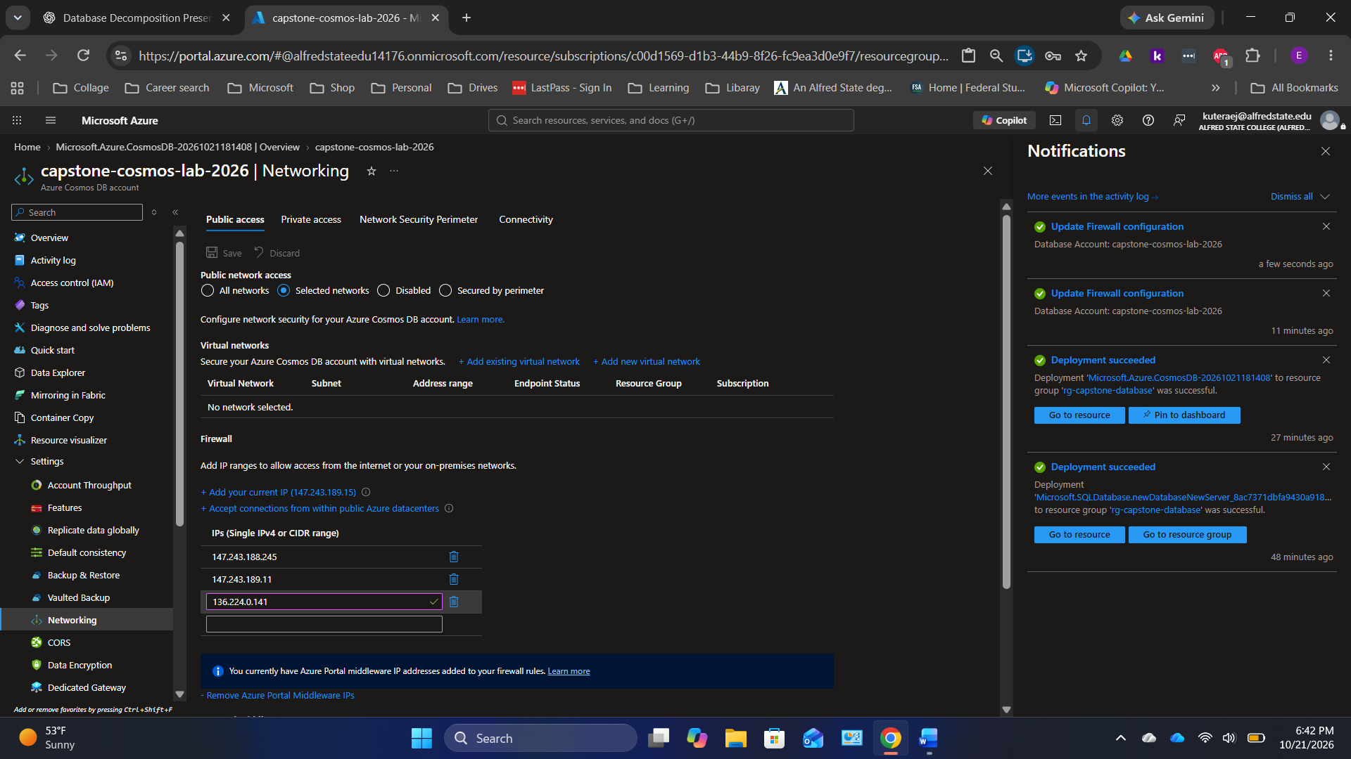
Original screenshot 40 of 44 — preserved in upload order.

Screen 41 — Azure Cosmos DB — Laptop document saved
Do this: Verify product-101 appears in Items. Azure adds _rid, _etag, _self and _ts metadata automatically.
Check: The Laptop document should show the expected price and hardware attributes.
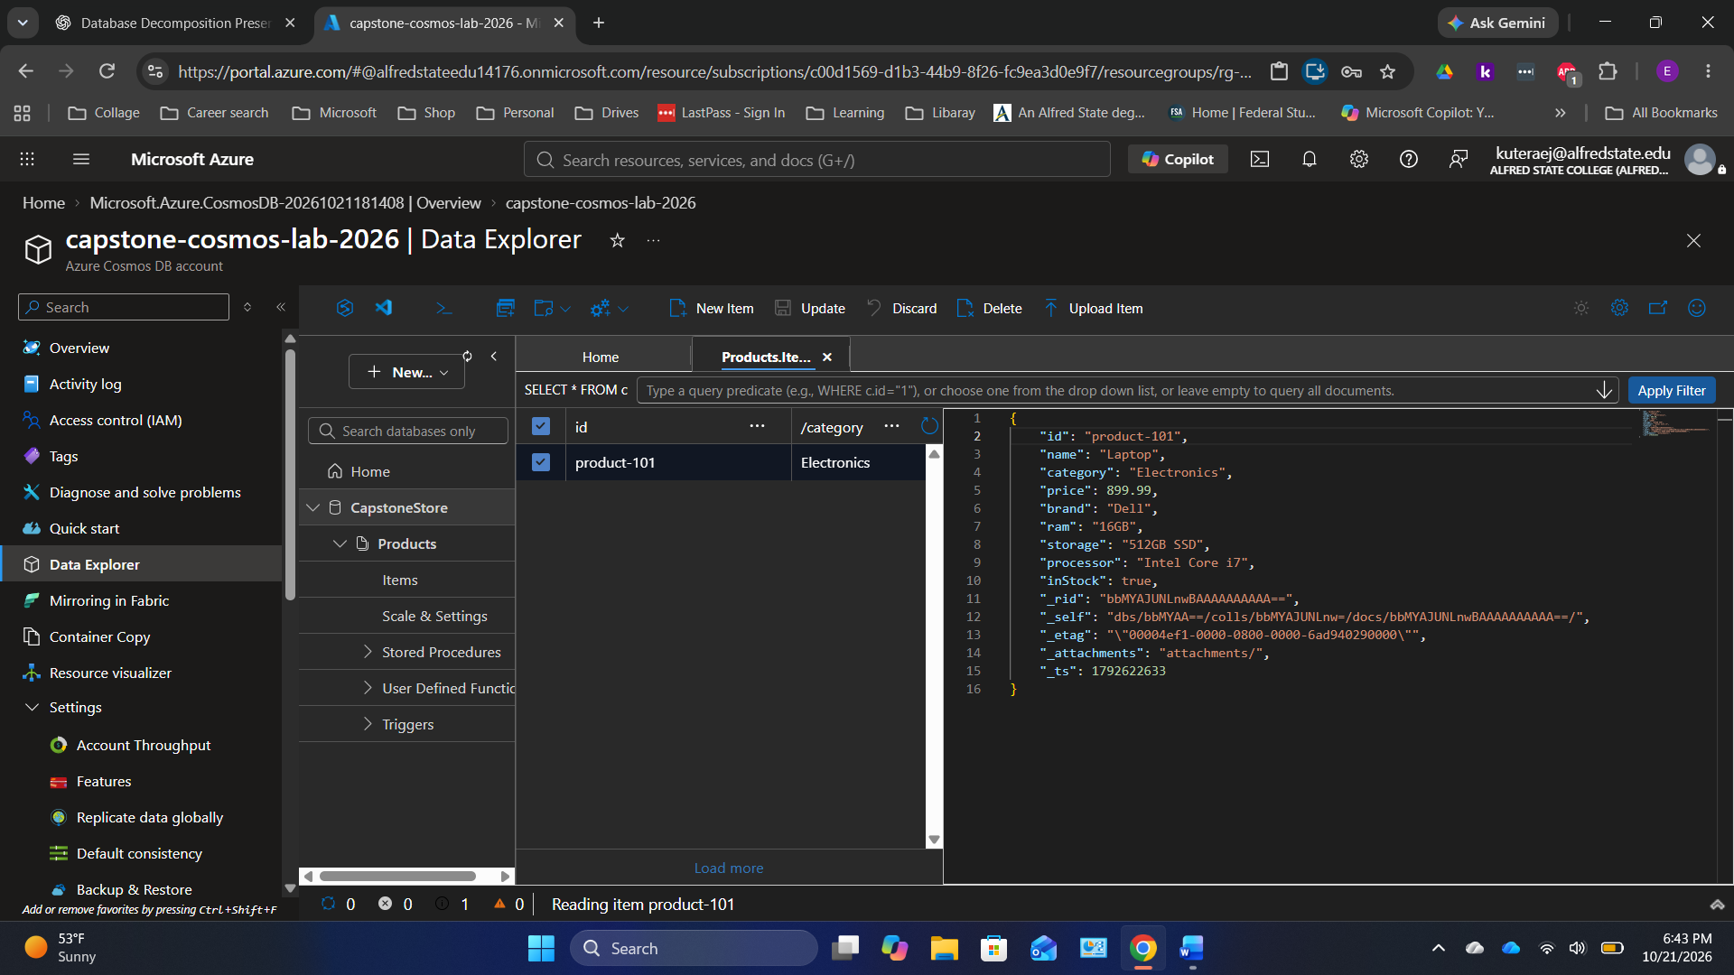
Original screenshot 41 of 44 — preserved in upload order.

Screen 42 — Azure Cosmos DB — Mouse document saved
Do this: Choose New Item and save the Mouse JSON from the JSON Code section as product-102.
Check: The Mouse has wireless, dpi and color fields, unlike the Laptop.
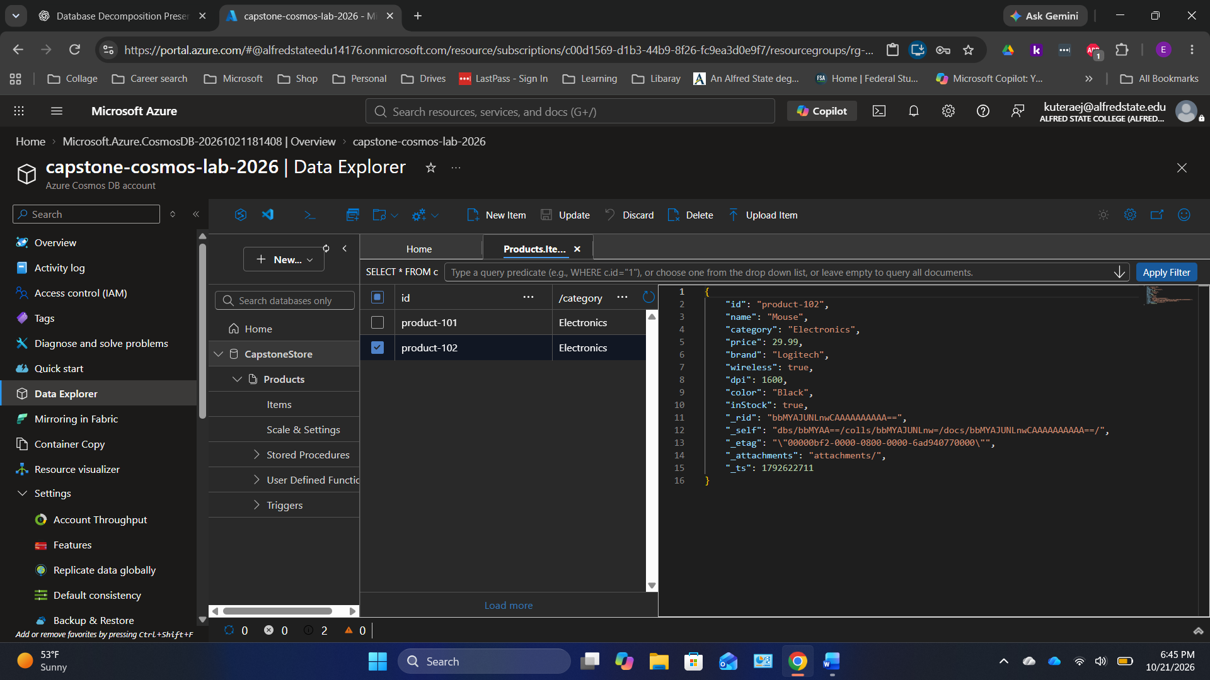
Original screenshot 42 of 44 — preserved in upload order.

Screen 43 — Azure Cosmos DB — Keyboard document saved
Do this: Choose New Item and save the Keyboard JSON from the JSON Code section as product-103.
Check: The Items list now contains three documents.
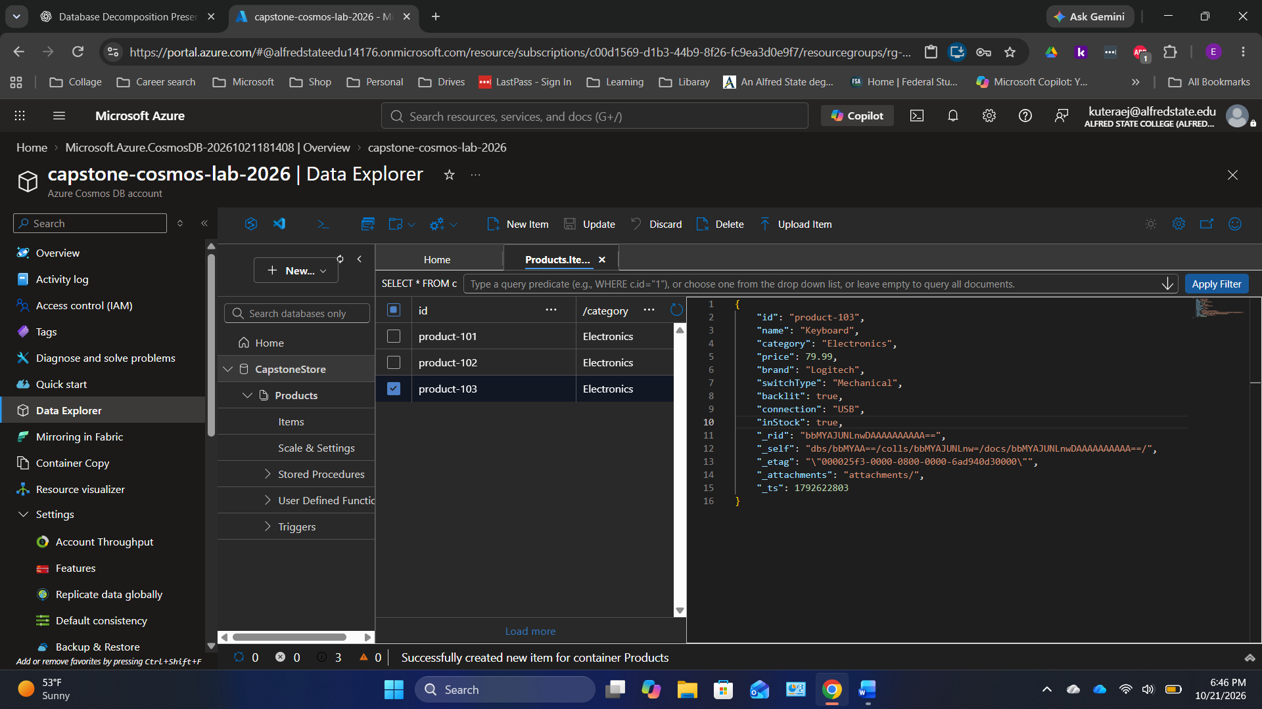
Original screenshot 43 of 44 — preserved in upload order.

Screen 44 — Azure Cosmos DB — query products by price
Do this: With Products selected, click New SQL Query. Paste the Cosmos query from the Query section, then select Execute Query.
Check: Expect three documents sorted by price: Laptop, Keyboard, Mouse.
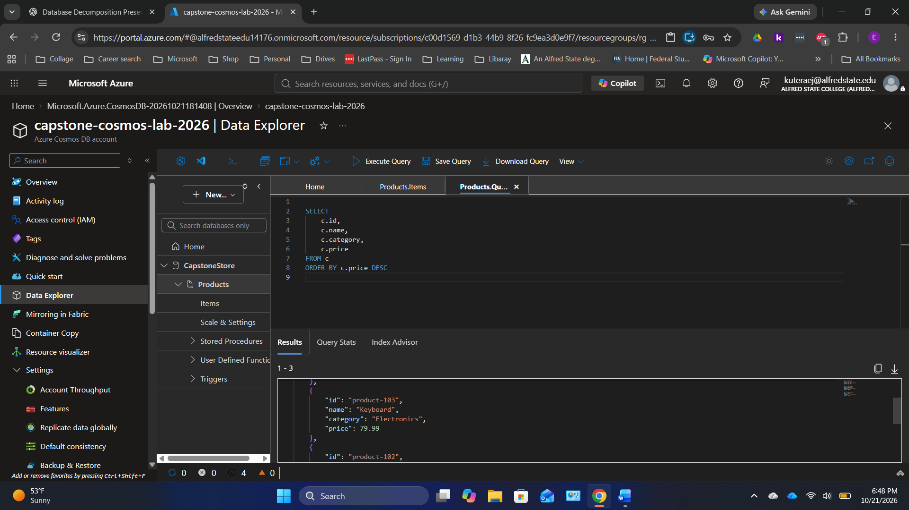
Original screenshot 44 of 44 — preserved in upload order.

SQL Code — Create tables
Use these commands in Azure SQL Query editor only once on a new blank database.
CREATE TABLE dbo.Customers (
customer_id INT PRIMARY KEY,
customer_name VARCHAR(100) NOT NULL,
customer_email VARCHAR(150) NOT NULL
);
CREATE TABLE dbo.Orders (
order_id INT PRIMARY KEY,
customer_id INT NOT NULL,
product VARCHAR(100) NOT NULL,
CONSTRAINT FK_Orders_Customers FOREIGN KEY (customer_id)
REFERENCES dbo.Customers(customer_id)
);

SQL Code — Insert example rows
INSERT INTO dbo.Customers (customer_id, customer_name, customer_email) VALUES
(1, 'John Smith', 'john@email.com'),
(2, 'Sarah Lee', 'sarah@email.com'),
(3, 'Michael Brown', 'michael@email.com');
INSERT INTO dbo.Orders (order_id, customer_id, product) VALUES
(101, 1, 'Laptop'), (102, 1, 'Mouse'), (103, 2, 'Keyboard'),
(104, 3, 'Monitor'), (105, 2, 'Headphones');

SQL Code — Query with INNER JOIN
SELECT c.customer_name, c.customer_email, o.order_id, o.product
FROM dbo.Customers AS c
INNER JOIN dbo.Orders AS o ON c.customer_id = o.customer_id
ORDER BY o.order_id;
Expected: five rows, with customer information obtained through the foreign-key relationship.

Cosmos DB JSON Code — Three example documents
Data Explorer > CapstoneStore > Products > Items > New Item. Save each JSON document separately. Ensure category is present because /category is the partition key.
{
"id": "product-101", "name": "Laptop", "category": "Electronics",
"price": 899.99, "brand": "Dell", "ram": "16GB",
"storage": "512GB SSD", "processor": "Intel Core i7", "inStock": true
}
{
"id": "product-102", "name": "Mouse", "category": "Electronics",
"price": 29.99, "brand": "Logitech", "wireless": true,
"dpi": 1600, "color": "Black", "inStock": true
}
{
"id": "product-103", "name": "Keyboard", "category": "Electronics",
"price": 79.99, "brand": "Logitech", "switchType": "Mechanical",
"backlit": true, "connection": "USB", "inStock": true
}

Cosmos DB Query — Sort by price
SELECT c.id, c.name, c.category, c.price
FROM c
ORDER BY c.price DESC
Expected order: Laptop ($899.99), Keyboard ($79.99), Mouse ($29.99).

Student check and discussion
[ ] I created the two SQL tables.
[ ] I inserted three customers and five orders.
[ ] My SQL INNER JOIN returned five rows.
[ ] I created a Cosmos DB Products container with /category as partition key.
[ ] I saved all three product documents.
[ ] My Cosmos DB query returned three products sorted by price.
Discussion: What repeated customer fields did decomposition avoid? Which attributes are different across the product documents? Why might a real application choose SQL for orders and Cosmos DB for the product catalog?

